An effective Speaker
Description of norms | How might this norm be a challenge? Please consider: culture, nationality, ability, upbringing, and mood/ circumstance.
Eyes/ Eye brows
Volume
Tone of voice
Pace
Hands
Stance
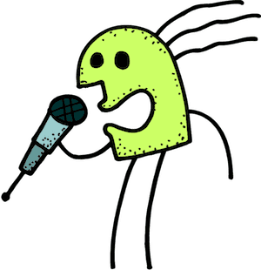

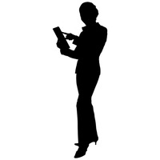

An effective Listener
Description of norms | How might this norm be a challenge? Please consider: culture, nationality, ability, upbringing, and mood/ circumstance.
Eyes/ Eye brows
Mouth
Head
Back
Hands
Feet/ Stance

