Schweinfurt–Regensburg mission
August 10, 2009
Only1rob
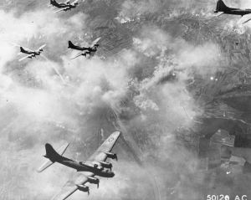
“I wish I could go pa!”
The gruff, bearded man turned and looked at the child critically before finally saying “No. No you do not”
“Why pa?”
He sighed “Because my boy, it’s a fool’s task. Those kids, no matter how many guns they take with them, are goin’ to die and it is going to be a waste. We will have less people here to help with the defenses and more importantly all those young men will have lost their lives, if they’re lucky!”
“I don’t understand pa. They said they would save us all! That there would be no more attacks!”
The man rubbed his eyes, tired from months of fighting, months of repairing walls, doors, knives and guns. Months of death, undeath and seeing friends dying only to return with murder in their eyes.
“Let me tell you a story son. During the Second World War the United States launched a daring air raid, from England against the Germans. Deep into enemy territory they flew, hundreds of bombers, on a mission to destroy the Luftwaffe’s plane factories. They were going to stop the entire air war in one decisive strike”
The child’s eyes were wide eyed as the man continued to talk “Those boys are going deep into the city and they are going to stir up a hornets’ nest the likes of which we have not seen. There must have been more than a million people there when the plague came, and there they remain. And just like back then they are going into something with little understanding of what they really face. Mark my words child, at best things will remain the same at worst the whole damn city will empty out and head this way. Either way we will be missing our strongest men and our best weapons.”
The two remained silent as the wind whispered through the tree leaves above them until the boy quietly asked “You really think it’s that bad pa?”
“I do son”
Again they fell silent, listening to the leaves and distant bird song across the surrounding countryside.
“Pa, what happened to the planes?”
The man rubbed his beard thoughtfully and shook his head at the gathering group of men at the town’s gates “They failed son. Only a few returned, the rest were shot down and killed.”

