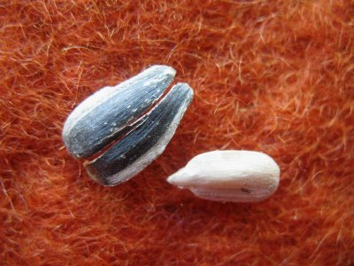
Response Types
-Adapted from R. Cooke “Reading and Journal Topics”

4As
-Assumptions you or the author made.
-Agreements you have.
-Arguments you have.
-Aspirations you have for your life based on the ideas.

Circle, Square, Triangle
-A question still circling your mind.
-Something that squares with your thinking.
-Something that forms a base for new knowledge.

Seed, Bud, Bloom
-Seed- record thoughts that need time to germinate.
-Bud- Record thoughts that are further along.
-Bloom- Record thoughts that can be implemented tomorrow.

Annotating Text
-Question—what else do you need to know?
-Define— word, phrase, concept
-Visualize—smell, taste, touch, or hear
-Predict—Based on evidence
-Connect—to self, world, text
-Determining importance—
why is this important?
-Inference—It says, I know, and so…
-Synthesis—conclusion from many pieces of evidence.

Right on, Surprise, Hmmm…
Right on—Yes!
Surprise—different from your assumption
Hmmm—made you reflect

This will be recorded in the Reading and Writing Strand

Reading/ Writing Strand
Reading Response Rubric

Categories | 50-59%  (Level 1) | 60-69%  (Level 2) | 70-79%  (Level 3) | 80-100%  (Level 4)
Knowledge and Understanding - Subject-specific content acquired in each course (knowledge), and the comprehension of its meaning and significance (understanding)
Understanding of content of short story | demonstrates limited understanding of the short story. Includes few details. | demonstrates some understanding of the short story. Includes some details. | demonstrates considerable understanding of of the short story. Includes details. | demonstrates thorough and insightful understanding of content
Thinking - The use of critical and creative thinking skills and/or processes
Use of processing skills  (e.g., drawing inferences, synthesizing). | uses processing skills with limited effectiveness | uses processing skills with some effectiveness | uses processing skills with considerable effectiveness | uses processing skills with a high degree of effectiveness
Communication - The conveying of meaning through various forms
Expression and organization of ideas and information. (Eg.) The thinking matches content of idea. | expresses and organizes ideas and information with limited effectiveness. | expresses and organizes ideas and information with some effectiveness | expresses and organizes ideas and information with considerable effectiveness | expresses and organizes ideas and information with a high degree of effectiveness

Comments:

Final Mark:

Late Marks:

