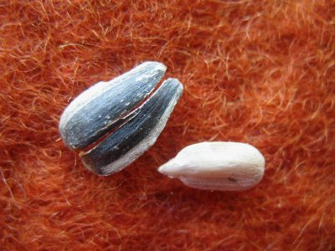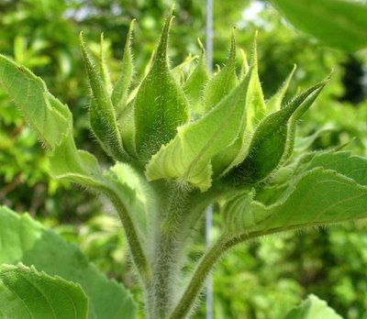
Response Types
-Adapted from R. Cooke “Reading and Journal Topics”

4As
-Assumptions you or the author made.
-Agreements you have.
-Arguments you have.
-Aspirations you have for your life based on the ideas.

Circle, Square, Triangle
-A question still circling your mind.
-Something that squares with your thinking.
-Something that forms a base for new knowledge.

Seed, Bud, Bloom
-Seed- record thoughts that need time to germinate.
-Bud- Record thoughts that are further along.
-Bloom- Record thoughts that can be implemented tomorrow.

Annotating Text
-Question—what else do you need to know?
-Define— word, phrase, concept
-Visualize—smell, taste, touch, or hear
-Predict—Based on evidence
-Connect—to self, world, text
-Determining importance—
why is this important?
-Inference—It says, I know, and so…
-Synthesis—conclusion from many pieces of evidence.

Right on, Surprise, Hmmm…
Right on—Yes!
Surprise—different from your assumption
Hmmm—made you reflect

