Connect
Make 6-8 specific connections to this text.
- text-to-text,
- text-to-world, and
- text-to-self connections.

To-Text To-world

To –self

In one sentence, explain how one of these connections might improve or extend your understanding.
________________________________________________
___________________________________________
Determining Importance

Identify five detailed facts or quotes (include page) from the text. Use the ranking ladder to order these facts from least to most important in terms of understanding the text. Explain your reasoning.
least important … most important

Predict
Use the graphic organizer to record detailed predictions about who the target audience would be. OR of what would happen next if the story continued. Quotes require page numbers please.
Prediction of audience: age, gender, location, income/ profession, political leaning, ethnic background, English language proficiency, prior learning | Both prediction types require text/ evidence and explanation of logic.

Inference
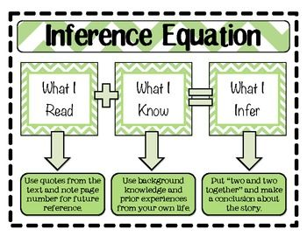

Record three inferences you had to make to fully understand the text.
It says | I say | And so…
Quote requires page ( )

Summarize:
Somebody/ Wanted/ But/ So
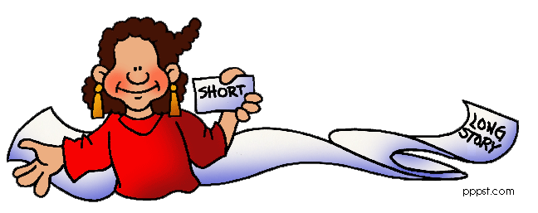
Complete the Somebody/ Wanted/ But/ So graphic organizer to summarize the text. Use your own words.

Somebody | Wanted |  | But | So | So

Visualize
Provide a short quote from the text (include page) | Enhanced the quote by using your imagination and your experiences. *Include adjectives, metaphors or similes.
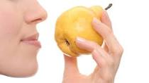 | I smell and taste
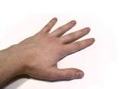 | I feel/ touch
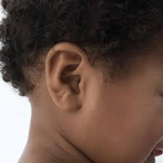 | I hear
 | I see
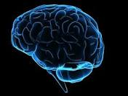 | Overall, this visualization helps or impacts the reader because

Define

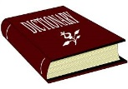

Which words do you need to look up before you can understand this? Write a brief definition: AND consider, why did the author pick this word?

Word:
Define:

Why this word? _________________________________

Word:
Define:

Why this word?
_________________________________

Word:
Define:

Why this word? _________________________________

Word:
Define:

Why this word? _________________________________
Question
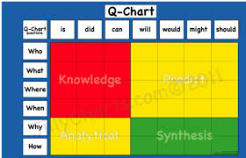
Use the Q-Chart to create 3 higher level thinking questions and provide at least 2 different possible answers to make sure it is level 3 or 4.
Question 1

Answers
-

-

Question 2
Answers
-

-

Question 3
Answers
-

-

*Synthesize
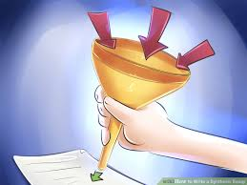

Theme

(Theme is a full-sentence, opinion or stance that the author has hidden throughout the story. Avoid clichés, morals, questions or plot when thinking theme.)
Example or quote | Example or quote | Example or quote
Link (explain why the evidence proves your big idea) | Link (explain why the evidence proves your big idea) | Link (explain why the evidence proves your big idea)
Reading Rubric
Name:______________
Notes: | 50-59%  (Level 1) | 60-69%  (Level 2) | 70-79%  (Level 3) | 80-100%  (Level 4)
Knowledge and Understanding -
 | The student:
Organizes and formats as graphic organizer requires | demonstrates limited knowledge of organizing and formatting | demonstrates some knowledge of organizing and formatting | demonstrates considerable knowledge of organizing and formatting | demonstrates thorough knowledge of organizing and formatting
Thinking - The use of critical and creative thinking skills and/or processes
 | The student:
Examples are  1. unique  2. specific  3.appropriate | Provides limited examples. Rarely provides page. | Provides some examples and sometimes provides page number. | Provides considerable examples. And often provides page number. | Provides many different and suitable examples. And always provides page number.
Analysis (links) | Examples do not link to main idea. | Examples link to main idea but are not all or full explained by writer. | Examples are mostly linked to main idea. | All examples are all clearly and explicitly linked to main idea.
Communication - The conveying of meaning through various forms
 | The student:
1. Complete sentences  2. Variety and correct vocabulary  3. Capital letters  4. Apostrophes  5. Commas  6. Spelling | uses conventions of grammar, vocabulary, and spelling terminology with limited effectiveness | uses conventions of grammar, vocabulary, and spelling terminology with some effectiveness | uses conventions of grammar, vocabulary, and spelling terminology with considerable effectiveness | uses conventions of grammar, vocabulary, and spelling with a high degree of effectiveness
Attendance Number:_____

Final Level:_____

