PSA Task: /20 marks
- Review Logos, Ethos, and Pathos with your teacher
- View the PSAs provided
- Argue which is being targeted the most by that PSA
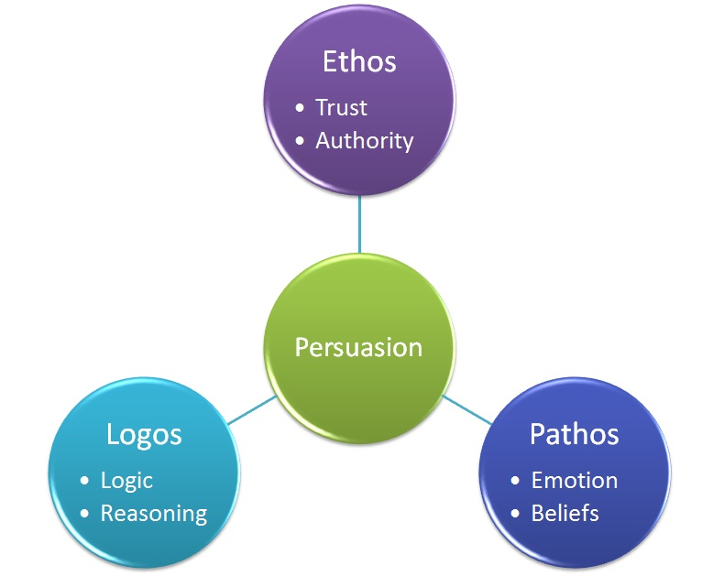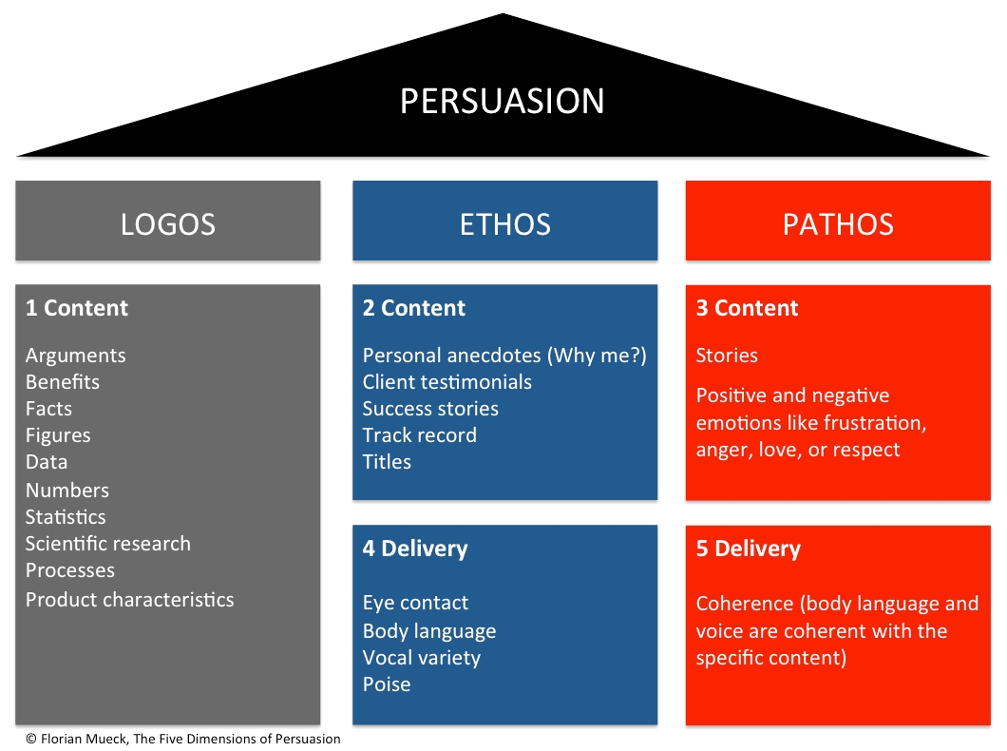
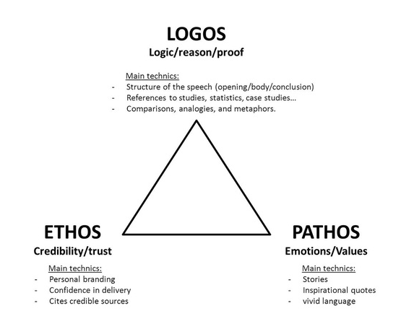
Topic of PSA | It mostly used a)logos, b)pathos or c)ethos (pick one) | My specific evidence is…  (/2) | Why might this appeal be best for this topic? OR explain if it was effective? Why or why not?  (/2)

