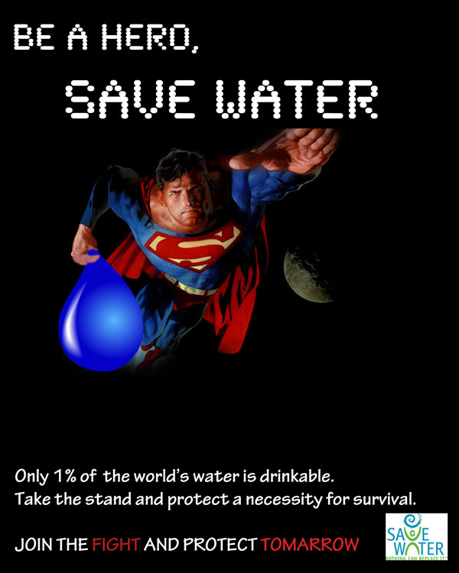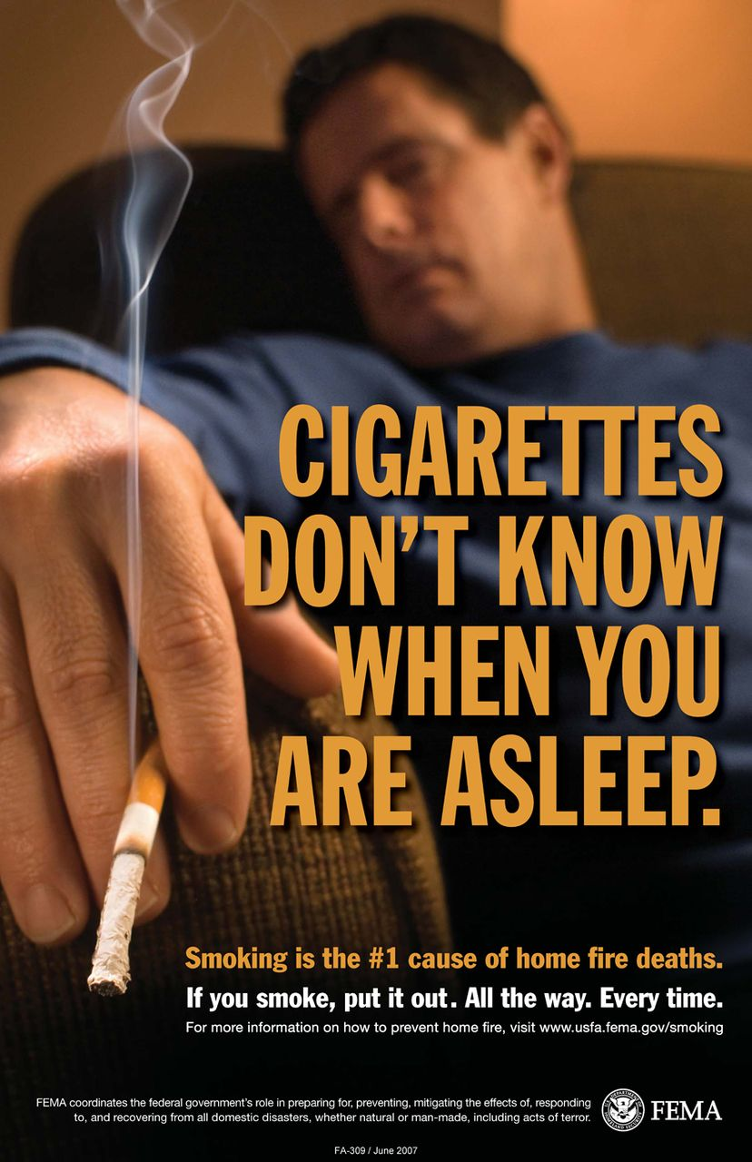

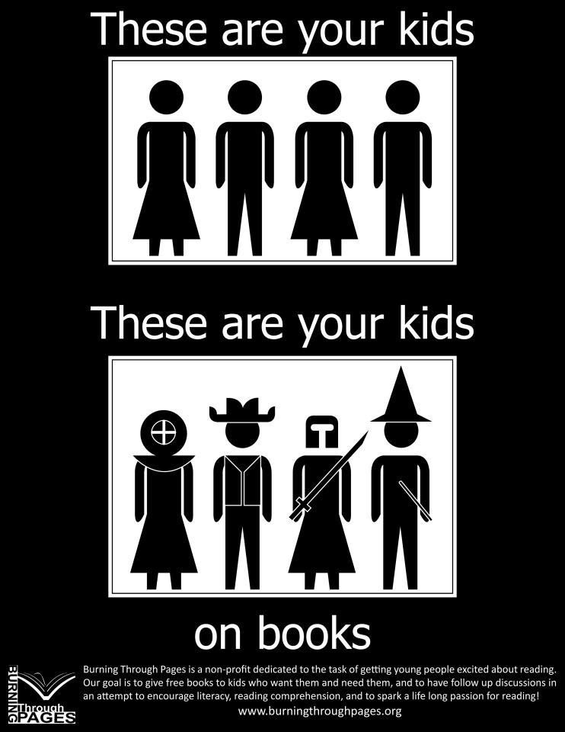

Which of the Advertisements (or PSAs) provided (media analysis)
/21 media strand
Task: For each question, please provide a specific answer (1) with specific evidence (1) and explanation (1) for your choice. OR, explain what makes this effective. There is a total of 3 points per question.
- Most detailed? Or colourful? (3 points)

- Most clear in their warning? (3 points)

- Most powerful statistic? (3 points)

- Most clear solution or prevention strategy? (3 points)

- Most creative? (3 points)

- Most appealing to a teenager? (3 points)

- Overall, which is the best, most effective PSA? (3 points)

