Properly Armed
Only1rob
November 19, 2010
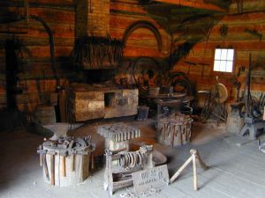
The large man raised his arm and slammed the hammer down on the molten metal blade across his anvil. Sparks shot across the room and bounced off the two shadow drenched figures in front of him. The taller of the two men, with a thoughtful look on his face spoke first.
“Why?”
The blacksmith looked at him and smiled.
The man filled the silence and continued his question, “There must be a dozen hardware stores in the city, take ten of your little villages men, go raid them, and you’ll have enough tools and weapons to last a life time, why make your own?”
The blacksmith, still smiling, turned the blade and brought the hammer down again, before hefting the red-hot weapon, inspecting the blade and thrusting it into the large barrel of water to his side. As the steam billowed into the air he looked at the two men and spoke.
“Lifetime is the keyword son. I, and we, around here, like ours to go on for a long time.” He walked across the room to a large rack, “When the ammo in the rifle you carry runs out and you’re down to hand to hand, and the only thing standing between you and your enemy is the weapon in your hand, will it be a cheap piece of metal you got at a hardware store? Or something made to keep oblivion at bay?” He pulled a short blade from the rack and hefted it, inspecting the glint of light as it played along the razor sharp edge.
“I see the hammer you have tucked in your belt, and it’s a pretty nice one, but it’s designed for hitting nails, not human flesh. When it gets wet, you must put it down and wipe your hands. You can’t do that in combat.” He thrust the blade, hilt first, at the second silent figure, who clumsily scooped it up, “Mine has a channel for blood, a hilt to protect your hand, leather grip to absorb your sweat and an edge to make the devil himself crap blood.” He smiled again and walked to the far door.
“I have two tied up outback; use your hammer on one and this on the other. Don’t come back until they’re both dead.”
As the two men walked out of the room, the blacksmith pulled another blade from the rack and set it on the table. He sat down, steepled his fingers and waited, listening to the dull rapid thuds coming from the other side of the wall. A few moments after the thuds faded away and a single sharp ‘Snikt’ sound echoed into the room, the door was pushed open and the two men walked back in. Both were covered in blood and the first, who held the hammer, was drenched in sweat.
Looking at the seated blacksmith and the blade on the table he dropped the hammer to the floor. “We’ll take two”

