Paragraph Types: In Class Note
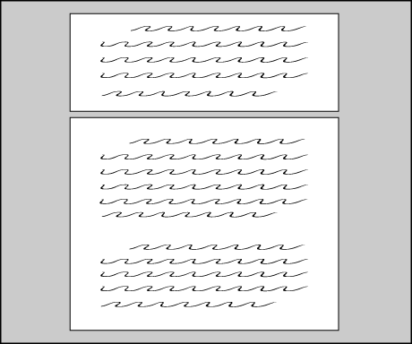
Paragraphs (overall things to know)
- A paragraph is made up of 8-10 related sentences
- The paragraph should follow one organization type
- Some types are
  - Personal
  - Descriptive
  - Procedural
  - Problem/ solution
  - Compare/ contrast
  - Cause/ effect
- Paragraphs are indented on the first line
- Paragraphs start with a topic sentence and end with a conclusion sentence
  - Topic sentence should:
    - Answer the question
    - Makes the type of paragraph clear
    - May organize the paragraph
    - A conclusion restates the topic sentence in a new way
- Always use your knowledge of grammar, capitals, and vocabulary
- Avoid slang and short forms

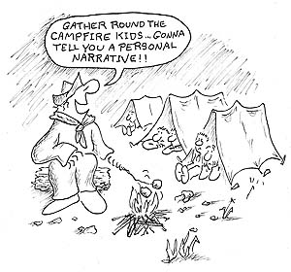
Personal paragraphs
- Use I, me, we, us
- Asserts a large, umbrella opinion called the Topic Sentence
- Proves opinion using mostly examples from your life or that you have seen as evidence
- Explains why this evidence is strong using analysis

Example: What is one character trait of a sibling/ family member?

My brother is extremely disgusting. My brother always leaves his dishes on the kitchen table. This is gross because there is still some food on it and that attracts bugs. He wears the same socks every day and refuses to change. This makes him revolting because his unwashed clothes start to smell, and by day three I can’t even stand next to him. Finally, he forgets to flush the toilet. When I come in next, I could just about scream—what’s more disgusting than that?

Suggested task for learning:
Highlight evidence/ examples in blue
Highlight analysis/ links/ explanations in yellow
Underline topic sentence and conclusion, are they connected?
Put a check mark beside every personal pronoun (I, me, my, we, us)

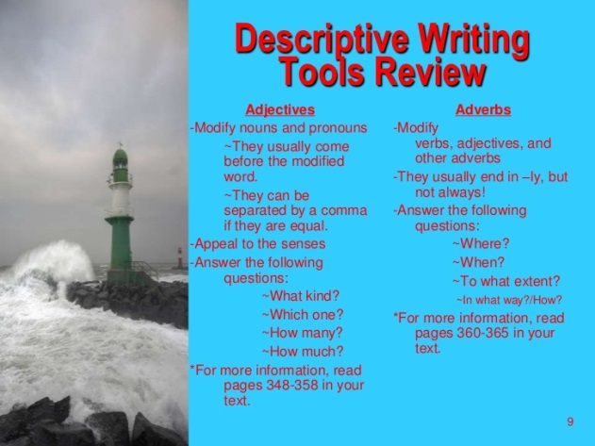

Descriptive paragraph
- A descriptive paragraph’s focus is to paint a complete image in the reader’s mind
- Starts with a topic sentence that makes its descriptive focus clear
  - For the content of the paragraph, the writer should use a variety of tools to allow the reader to feel like they are there and can experience what is being described
- Provide details that appeal to each human sense
    - Smell, Taste, Touch, Sound, Sight
- Use poetic devices like metaphors, similes, and onomatopoeia
- It was like a fog lifted from my mind
- Use adjectives
- Include colours, shapes, structure or organization
- smart, aggressive, kind, rad, wicked, awesome
- Use adverbs
          - Quickly, gracefully, beautifully, swimmingly

Descriptive paragraph cont’d

Example: Describe a setting in Game of Thrones
In Game of Thrones the Stark’s ancestral home of Winterfell is mighty against its enemies and yet peaceful and comfortable to its family. Winterfell’s castle is far North on the map of this ancient and magic world of Westeros. Winterfell’s first weapon against attackers is that the North is known to be as cold as the pits of hell. But, inside the majestic Stark castle stays warm as it was constructed atop of a deep, warm spring of water that gurgles through the thick and rough castle walls. The high, turreted, grey, and curving castle is an effective and powerful fortress against attack, and Starks seem only to falter due to the internal trickery of false-friends. Also, Winterfell is surrounded by the beautiful sacred groves of heart-trees. Starks kneel on whispering crispy leaved forest floor, bow their brunette and red heads, and mumble prayers to the trees who represent a spiritual gateway to their Old gods. The trees have white smooth, crying faces and are topped with silky and rich leaves. The red of the leaves and the muddied white façade are appropriate symbols of the stark- contrast between the typical tough exterior and the warm interior of the Starks and their home.

Suggested task for learning: Highlight adjectives in yellow. Highlight adverbs in green.
Underline all sensory description words. Star all metaphors, similes, onomatopoeia
Procedural paragraph
- Uses chronological order as organization (starts at the beginning and moves forward step by step in time)
  - Uses words like “first, next, further, then, afterwards” to maintain structure
- May describe how something has changed over time
- May instruct on how a task is performed

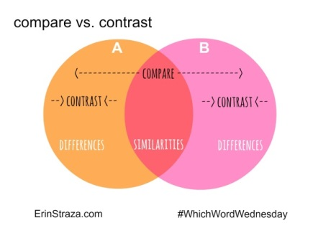

Compare and Contrast paragraph
- Topic sentences (1 per paragraph and 2 total) describes the two topics that are the focus of the paragraphs
- For a level 4, T.S. one will also state a major similarity and T.S. two will state the major or overarching difference
- Conclusion sentences (2 total) restate focus in new words
- Similarities
  - Paragraph one’s body includes facts, statistics, and examples that are the same or relative similarities (largely similar)
  - You quote or rephrase a detail from topic A then a detail from topic B
  - Please note, that sometimes A and B can be merged into one fact.
    - Example Trump care costs 1,000,000 dollars (A)
    - Obama care costs 2,000,000 dollars (b)
  - In the next sentence, you explain how they are similar
  - Repeat this structure twice
    - TS
    - A
    - B
    - Explain how similar
    - A
    - B
    - Explain how similar
    - Conclusion
- Differences
  - Paragraph two’s body includes facts, statistics, and examples that are different
  - You quote or rephrase a detail from topic A then a detail from topic B
  - In the next sentence, you explain how they are different
  - Repeat this structure twice
    - Topic sentence
    - A
    - B
    - Explain how different
    - A
    - B
    - Explain how different
    - CS
Compare contrast Example Paragraphs

Bush vs. Trump or Dumb and Dumber
Similarities
Trump and Bush have some similarities in the ways they are both viewed as unintelligent men. Trump’s resistance to reading has led to some business problems caused by not reading the contract. On the other hand, Bush sometimes misread his teleprompter or read it very slowly, and some have even theorized that Bush may have a mild case of dyslexia. Their visible and reported trouble with reading brings these two American Presidents together. Besides this, they also are not strong verbally. Trump said the word “bigly” once and often swears during speeches, and swearing has been said to indicate a lack of vocabulary. Similarly, Bush was also known for misspeaking and once said his opponents “misunderestimated me.” Both men have publically stated words that do not exist and and those mistakes have become a part of their public perception. Lastly, Trump has stated many things that are inconsistent with what he has said before. For example, he once stated that he is pro-choice when it came to abortions. And now, he says that “there must be a consequence” if women choose an abortion. At the same time, Bush and his administration are known to have misled the public on the existence of Weapons of Mass Destruction in Iraq in order to justify starting a war. Last, both men have acted against the scientific community. Trump’s administration is active against research on Global Warming, while Bush delayed stem cell research in the USA for the eight years of being in office. All of these intances and more have led to both men being similarly perceived as less intelligent.

While both men may lack intelligence, Trump is seen to be racist whereas Bush is not viewed in this light. Trump focused his election around racism and building a massive border-wall that would divide The United States from its neighbouring nation, Mexico. Trump stated that the Mexicans come to the United States that they are “sending rapists.” Trump’s remarks seemed fuel hatred towards minority groups. Bush, on the other hand, happily recognized that USA was “a nation of immigrants”. Bush’s administration was known to enforce strict laws on people who had entered illegally. For example, he shortened the holding time of people found to be in the USA illegally, but he did not tend to encourage hatred towards Mexican-Americans as a whole. Trump rallies have been known to visibly and violently throw out even silent and non-violent black protesters. Whereas, George W’s campaigns were not known for being divided by race. In fact, Bush had a more inclusive and diverse administration than any Republican and his top advisors included strong black people such as Colin Powell and Condoleezza Rice. Horribly, Trump’s 2016 campaign was supported by powerful KKK members including “Pastor” Thomas Robb who wrote in the KKK newspaper, The Crusader, that he was very excited to “make America Great white again”. Admittedly, Bush was not perfect when it came to racial matters, for example, the war in Iraq and the 9/11 attacks on American soil has worsened lives for many Islamic Americans. However, Bush has recently come out against Trump and is not support Trump, regardless of being Republican and Bush stated that “he does not like racism and for people to feel alienated”. Bush’s speaking directly against racism is a part of why Trump is viewed as racist while his predessor, Bush, is not.
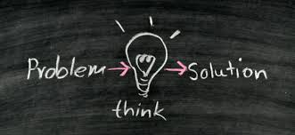
Problem and Solution paragraphs (typically broken into two paragraphs)
- Topic sentence establishes the problem
- Describes one issue (large, negative force in the world)
  - Provide facts, examples, and anecdotes which prove
  - Explain that this is a substantial threat
  - Conclude
- Topic sentence establishes the best possible way to prevent this issue
- Describes one way to help or reduce this grievance
  - Provides facts, examples, and anecdotes which prove
  - Explain that this is a reasonable way to lessen that same negative event
  - Conclude

Problem Paragraph—argue it is a problem
TS
E 1
L
E 2
L
E 3
L
CS

Solution Paragraph—argue that you have a good solution
TS
E 1
L
E 2
L
E 3
L
CS

