Mythology Investigation
(R) Research notes (page 2-3) due: ____________________________
(W) Paragraphs (page 4-6) due: ____________________________
(O) (M) Presentation (Page 9-11) : ______________________________
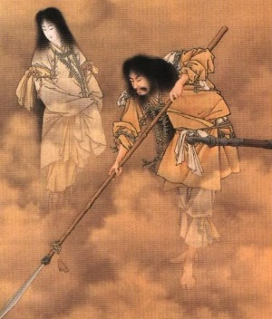
Step 1: Select 1 kind of mythology from the list below:
African | Egyptian | Inca
Aztec | Greek | Japanese
Celtic | Hindu | Norse
Chinese | Inuit | North American Native (narrow down)

Step 2: Use only reliable sources. I suggest:
http://pantheon.org/
https://www.britannica.com/topic/myth

Step 3: Research
Topic | Mythology Research Notes  (Reading mark) | Source  (media mark)
Who are the main gods? List 4-5 of the central gods and what they have control over here

Ex. Zeus- heavens lightning
Select ONE god from the list above and summarize one important myth or story about theme here:

USE S/W/B/S Or beginning/ middle/ end

How did you know this story might be important?

Where does that god live?

Ex, Zeus lived in Olympia
Who is your god related to? What is their creation story.

Does your god have any other names?

OR special powers?

Did your god ever interact with humans? If so, what was their attitude towards them?

What does your god wear?
OR, are there any important symbols of your god?

How does your god pass their time?

Is there anything else you think we would enjoy about your god?

Any other important stories about your god?

Does your god appear in any modern stories or movies? If so, list here.

Did they do a good job with your god in the modern story? Why or why not?

Rubric: Research (Media and Reading Strand)
Student: Task:
Date: Assessor: Self Peer Teacher

Criteria | Level 1 | Level 2 | Level 3 | Level 4
Knowledge/  Understanding  • researched information shows variety  Media | ❑ few accurate and relevant facts, statistics, authorities | ❑ some accurate and relevant facts, statistics, authorities | ❑ considerable accurate and relevant facts, statistics, authorities | ❑ many well-chosen, accurate, and relevant facts, statistics, authorities
Thinking/Inquiry  • Student is focused  Reading | ❑ research shows limited focus | ❑ research is somewhat focused | ❑ research is focused | ❑ research is effectively focused
Communication
• language for organization  Reading | ❑ Instructions and graphic organizer are minimally used | ❑ Instructions and graphic organizer are somewhat used | ❑ Instructions and graphic organizer are mostly used | ❑ Instructions and graphic organizer are used OR a logical alternative is created
Application
• sources are documented  Media | ❑ sources are limited; few are carefully documented | ❑ some sources are appropriate and well documented | ❑ most sources are appropriate and well documented | ❑ all or almost all sources are appropriate and well documented

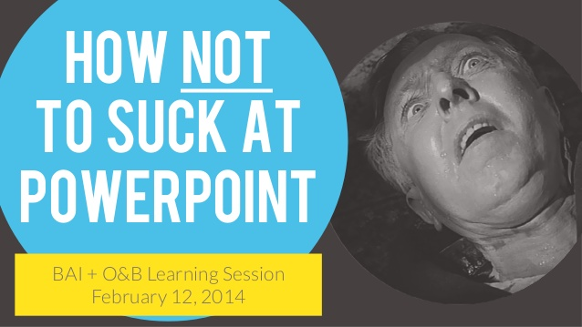

Final Step: Make a prezi or powerpoint to showcase a big idea of what you have learned about ONE of the mythologies of your choice. (Media and Oral Strand)

Tips for success: (Rephrased from the rubric)

- You may choose to organize your presentation based on the original research questions OR based on your own organization.

- Your media presentation should have images on every screen/ slide. The images all support your words and somewhat entertain your audience. People do not want to read your script, so do not write out what you want to say on the slides. I suggest that you use ONE modern, clear, bright image on each slide with minimal or no words.

- You may choose to have a script or cue cards. But, you should not look on the screen during the presentation. Rather, your focus (eyes and posture) should be towards the audience.

- Your presentation should be formal. So use your best words, dress your best, and bring your positive energy.

- You may choose to go above and beyond to assess their knowledge. What did they actually learn? Play a quick 3-5 min game, give a quiz, encourage participation.

Media Presentation: (Oral)

Criteria | Assessment | Notes/Comments
Knowledge/Understanding
• presentation focused around a clear central idea or purpose | 0 1 2 3 4
• content is accurate, relevant, and complete | 0 1 2 3 4
Thinking/Inquiry
• shows creativity and originality that engages the audience | 0 1 2 3 4
Communication
• organizes material logically | 0 1 2 3 4
• shows a sense of audience and purpose | 0 1 2 3 4
Application
• speaks clearly and audibly delivers presentation smoothly; presenter appears relaxed and at ease (e.g., well rehearsed) | 0 1 2 3 4
• uses appropriate gestures and body language | 0 1 2 3 4
• uses correct language and grammar | 0 1 2 3 4

Media Presentation: Visual (Media)

Criteria | Assessment | Notes/Comments
Knowledge/Understanding
• enhances the message with relevant images (and words) | 0 1 2 3 4
Thinking/Inquiry
• engages the viewer with creativity and originality | 0 1 2 3 4
Communication
• choice of images and words show a sense of audience and purpose | 0 1 2 3 4
• material is organized with attention to visual elements (e.g., balance, contrast, emphasis, movement, patterns, unity) | 0 1 2 3 4
Application
• tools and techniques of the media are used effectively | 0 1 2 3 4

