Mythology Investigation
(R) Research notes (page 2-3) due: ____________________________
(W) Paragraphs (page 4-6) due: ____________________________
(O) (M) Presentation (Page 9-11) : ______________________________
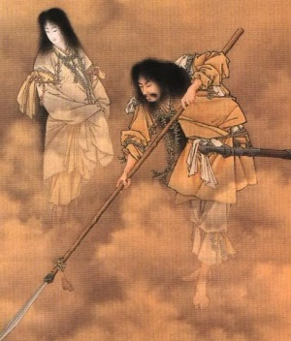
Step 1: Select 2 different mythologies from the list below:
African | Egyptian | Inca | North American Native
Aztec | Greek | Japanese | Polynesian
Celtic | Hindu | Navajo | Roman
Chinese | Inuit | Norse | Sumerian
Step 2: Scan various reliable online sources to assess how they work:
http://pantheon.org/
https://www.windows2universe.org/mythology/mythology.html
https://en.wikipedia.org/wiki/List_of_mythologies#Fictional_mythologies
https://www.britannica.com/topic/myth
Step 3: Read at least 2 short myths from 2 of your choices (for a total of 4)
1 | 3
2 | 4
Step 4: Use a different piece of paper to take detailed research notes. The question to keep in mind is, what does your mythological stories share and what about them is unique?
Topic  How does your mythology explain or envision the… | Mythology 1: _______________  Provide 3-5 details (names, dates, places) | Source
Creation of the physical Earth OR sun OR moon OR seasons

creation of their gods
creation of humans
afterlife or underworld

life of one human hero or demi-god

Other mythical creatures:
Topic  How does your mythology explain or envision the… | Mythology 2: _______________  Provide at least 3-5 details (names, dates, places) | Source
Creation of the physical Earth OR sun OR moon OR seasons

creation of their gods
creation of humans
afterlife or underworld

life of one human hero or demi-god

Other mythical creatures: beasts or fairies
Step 5: Plan your Compare Contrast Paragraph 1
What is the overarching similarity between both mythologies (Topic sentence)

List the 2 specific ideas that the mythologies share
1
2
Example 1:
Details from mythology A (provide citation from research)

Detail from mythology B (provide citation from research)

Explain how that is similar

Example 2:
Detail from mythology A (provide citation from research)

Detail from mythology B (provide citation from research)

Explain how that is similar

Compare Contrast Paragraph 2
What is the overarching difference between both mythologies (Topic sentence)

List the 2 specific ideas that the mythologies do NOT share
1
2
Example 1:
Detail from mythology A (provide citation from research)

Detail from mythology B (provide citation from research)

Explain how that is different

Example 2:
Detail from mythology A (provide citation from research)

Detail from mythology B (provide citation from research)

Explain how that is different

Write out your two paragraphs without teacher-prompts: (attach lined paper if more space is required)
Creative title:

Rubric: Research
Student: Task:
Date: Assessor: Self Peer Teacher

Criteria | Level 1 | Level 2 | Level 3 | Level 4
Knowledge/  Understanding  • researched information shows variety | ❑ few accurate and relevant facts, statistics, authorities | ❑ some accurate and relevant facts, statistics, authorities | ❑ considerable accurate and relevant facts, statistics, authorities | ❑ many well-chosen, accurate, and relevant facts, statistics, authorities
Thinking/Inquiry  • Student is focused | ❑ research shows limited focus | ❑ research is somewhat focused | ❑ research is focused | ❑ research is effectively focused
Communication

• language for organization | ❑ Instructions and graphic organizer are minimally used | ❑ Instructions and graphic organizer are somewhat used | ❑ Instructions and graphic organizer are mostly used | ❑ Instructions and graphic organizer are used OR a logical alternative is created
Application

• sources are documented | ❑ sources are limited; few are carefully documented | ❑ some sources are appropriate and well documented | ❑ most sources are appropriate and well documented | ❑ all or almost all sources are appropriate and well documented

Paragraph Rubric:
Notes: | 50-59%  (Level 1) | 60-69%  (Level 2) | 70-79%  (Level 3) | 80-100%  (Level 4)
Knowledge and Understanding -
 | The student:
Organizes and formats as writing form requires ex.  1. Directional statements.  2. Organizing words: first, second.  3. Uses space to separate ideas. (indents new paragraphs) | demonstrates limited knowledge of organizing and formatting writing. | demonstrates some knowledge of organizing and formatting writing. | demonstrates considerable knowledge of organizing and formatting writing. | demonstrates thorough knowledge of organizing and formatting writing.
Thinking - The use of critical and creative thinking skills and/or processes
 | The student:
Specifics  1. unique  2. specific  3.appropriate | Provides limited examples. | provides some examples. | Provides considerable examples. | provides many suitable examples.
Analysis (links) | examples do not link to main idea. | examples link to main idea but are not all or full explained by writer. | examples are mostly linked to main idea. | all examples are all clearly and explicitly linked to main idea.
Communication - The conveying of meaning through various forms
 | The student:
1. Complete sentences  2. Variety and correct vocabulary  3. Capital letters  4. Apostrophes  5. Commas  6. Spelling | uses conventions of grammar, vocabulary, and spelling terminology with limited effectiveness | uses conventions of grammar, vocabulary, and spelling terminology with some effectiveness | uses conventions of grammar, vocabulary, and spelling terminology with considerable effectiveness | uses conventions of grammar, vocabulary, and spelling with a high degree of effectiveness

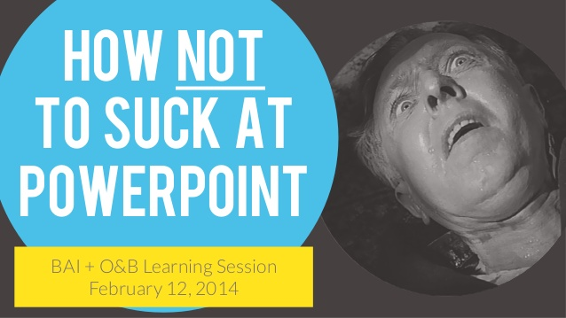

Final Step: Make a prezi or powerpoint to showcase a big idea of what you have learned about ONE of the mythologies of your choice.

Tips for success: (Rephrased from the rubric)

- You may choose to organize your presentation based on the original research questions OR based on your own organization.

- In addition, you should have ONE large message or purpose or theme. This message should be made clear in your intro, body, and conclusion of your presentation. Is your purpose to inform overall? Is your purpose to convey a certain message about your mythology? EX, Greek mythology is violent.

- Your media presentation should feature images on every screen/ slide. The images all support your words and somewhat entertain your audience. People do not want to read your script, so do not write out what you want to say on the slides. I suggest that you use ONE modern, clear, bright image on each slide with minimal or no words.

- You may choose to have a printed script. But, you should not look on the screen during the presentation. Rather, your focus (eyes and posture) should be towards the audience.

- Your presentation should be formal. So use your best words, dress your best, and bring your positive energy.

- You may choose to go above and beyond to assess their knowledge. What did they actually learn? Play a quick 3-5 min game, give a quiz, encourage participation.

Media Presentation: (Oral)
Name: Date:

Criteria | Assessment | Notes/Comments
Knowledge/Understanding
• presentation focused around a clear central idea or purpose | 0 1 2 3 4
• content is accurate, relevant, and complete | 0 1 2 3 4
Thinking/Inquiry
• incorporates logical analysis, generalizations, and conclusions | 0 1 2 3 4
• shows creativity and originality that engages the audience | 0 1 2 3 4
Communication
• organizes material logically | 0 1 2 3 4
• shows a sense of audience and purpose | 0 1 2 3 4
Application
• speaks clearly and audibly delivers presentation smoothly; presenter appears relaxed and at ease (e.g., well rehearsed) | 0 1 2 3 4
• uses appropriate gestures and body language | 0 1 2 3 4
• uses correct language and grammar | 0 1 2 3 4

Media Presentation: Visual (Media)

Criteria | Assessment | Notes/Comments
Knowledge/Understanding
• offers some depth, complexity, and/or sophistication in message | 0 1 2 3 4
• enhances the message with relevant images (and words) | 0 1 2 3 4
Thinking/Inquiry
• engages the viewer with creativity and originality | 0 1 2 3 4
Communication
• choice of images and words show a sense of audience and purpose | 0 1 2 3 4
• selection and juxtaposition of images and words show understanding of elements of design (e.g., line, shape, form, texture, colour, space, tone) | 0 1 2 3 4
• material is organized with attention to visual elements (e.g., balance, contrast, emphasis, movement, patterns, unity) | 0 1 2 3 4
Application
• tools and techniques of the media are used effectively | 0 1 2 3 4

