**My JETS Reading and Writing**

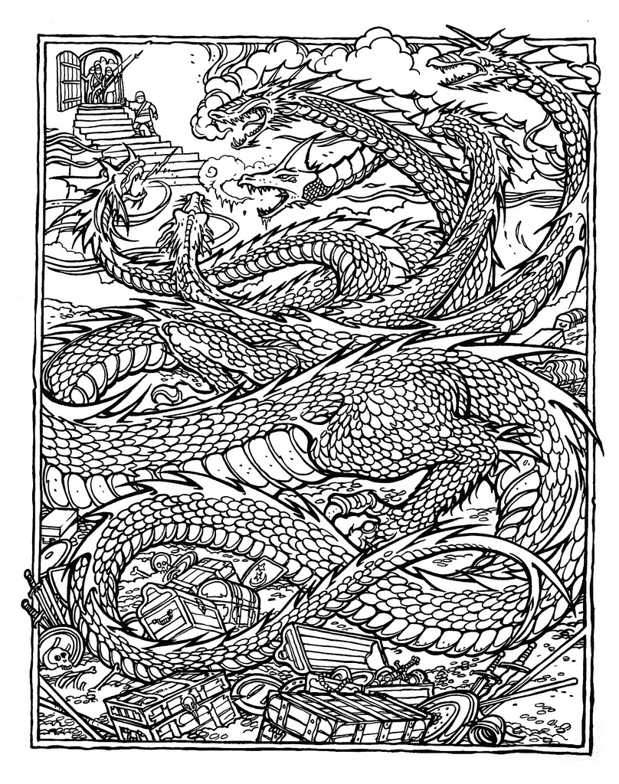

**My “TO READ” list**



|  |  |  |  |
| --- | --- | --- | --- |
| **Title of novel** | **Author Name** | **What made it sound/look good?** |  |
|  |  |  |  |
|  |  |  |  |
|  |  |  |  |
|  |  |  |  |
|  |  |  |  |
|  |  |  |  |
|  |  |  |  |
|  |  |  |  |
|  |  |  |  |
|  |  |  |  |
|  |  |  |  |

**Predict my Reading Rate using Math**

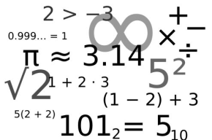

|  |  |  |  |  |
| --- | --- | --- | --- | --- |
|  |  | **TIMED** | **PREDICTIONS** | |
| **Date** | **Title of Text** | **Pages read in 10 min** | **Pages in 1 hour (60 min)**  **(____x 6)** | **Pages in 1 week should be (____x 7)** |
| 1 |  |  |  |  |
| 2 |  |  |  |  |
| 3 |  |  |  |  |
| 4 |  |  |  |  |

**Keep a Reading Log**

**Record the number of pages you ACTUALLY read each day**

|  |  |  |  |  |  |  |  |  |
| --- | --- | --- | --- | --- | --- | --- | --- | --- |
| **Week** | **Title of novel** | **M** | **T** | **W** | **TH** | **F** | **S/S** | **Total pages read this week** |
| 1 |  |  |  |  |  |  |  |  |
| 2 |  |  |  |  |  |  |  |  |
| 3 |  |  |  |  |  |  |  |  |
| 4 |  |  |  |  |  |  |  |  |
| Grand Total number of pages I ACTUALLY read in month 1 _________ | | | | | | | | |

**Writing Task #1**



**Connect- Write in a role- Pretend you are a character in your novel and write a journal or diary entry from their perspective.**

**Marking: Writing Strand /10**

|  |  |  |  |  |
| --- | --- | --- | --- | --- |
|  | **Level 1** | **Level 2** | **Level 3** | **Level 4** |
| **Knowledge** | Limited events/ knowledge of the novel. | Somewhat builds on events/ knowledge of the novel. | Mostly Builds on events/ knowledge of the novel. | Expertly Builds on events/ knowledge of the novel. Specific character names, events, setting etc. |
| **Inquiry** | Creative aspects to your writing are limited. | Somewhat adds creative aspects to your writing. | Mostly adds creative aspects to your writing. | Adds creative yet appropriate aspects to your writing. |
| **Communication** | Character’s voice and point of view are unclear. | Somewhat uses the character’s voice and point of view. | Mostly uses the character’s voice and point of view. | Uses the character’s voice and point of view. |
| **Application** | Paragraph format and organization. | Somewhat applies correct paragraph format and organization. | Mostly applies correct paragraph format and organization. | Applies correct paragraph format, organization, spelling, and vocabulary. |

Connect

_______________________________________________________________________________________________________________________________________________________________________________________________________________________________________________________________________________________________________________________________________________________________________________________________________________________________________________________________________________________________________________________________________________________________________________________________________________________________________________________________________________________________________________________________________________________________________________________________________________________________________________________________________________________________________________________________________________________________________________________________________________________________________________________________________________________________________________________________________________________________________________________________________________________________________________________________________________________________________________________________________________________________________________________________________________________________________________________________________________________________________________________

**Writing Task # 2**



**Prediction- Use evidence from the text to create a detailed prediction of what will happen next.**

**Marking: Writing Strand /10**

|  |  |  |  |  |
| --- | --- | --- | --- | --- |
|  | **Level 1** | **Level 2** | **Level 3** | **Level 4** |
| **Knowledge**  “This is reasonable because in the novel…” | Limited evidence provided for prediction. | Somewhat uses evidence for prediction. | Mostly uses evidence for prediction. | Expertly uses evidence for prediction. |
| **Inquiry**  “I think this because in my experience…” | Doesn’t explain prediction. | Somewhat explains thinking for prediction | Mostly explains thinking for prediction | Explains your thinking (background knowledge) for prediction. |
| **Communication** | Paragraph format and organization. | Somewhat applies correct paragraph format and organization. | Mostly applies correct paragraph format and organization. | Applies correct paragraph format, organization, spelling, and vocabulary. |

Predict

_______________________________________________________________________________________________________________________________________________________________________________________________________________________________________________________________________________________________________________________________________________________________________________________________________________________________________________________________________________________________________________________________________________________________________________________________________________________________________________________________________________________________________________________________________________________________________________________________________________________________________________________________________________________________________________________________________________________________________________________________________________________________________________________________________________________________________________________________________________________________________________________________________________________________________________________________________________________________________________________________________________________________________________________________________________________________________________________________________________________________________________________

**Writing Task with a Reading Strategy # 3**

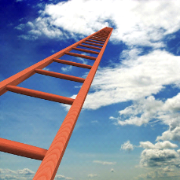

**Determine importance: Using your OWN criteria, rank the novels that you have read**

**Next, explain in one paragraph why or how you ranked the texts in that order?**

**Common Criteria: difficulty, interest, excitement etc.**

**Marking: Reading Strand /10**

|  |  |  |  |  |
| --- | --- | --- | --- | --- |
|  | **Level 1** | **Level 2** | **Level 3** | **Level 4** |
| **Knowledge** | Ladder with novels and authors is incomplete. | Somewhat completes ladder with novels and authors. | Mostly completes ladder with novels and authors. | Completes ladder with novels and authors. |
| **Knowledge** | Details from text is limited or missing. | Details from text somewhat supports your thinking. | Details from text mostly supports your thinking. | Details from text supports your thinking. |
| **Inquiry** | Doesn’t explain criteria | Somewhat explains criteria | Mostly explains thinking of criteria | Explains your thinking for criteria. |
| **Communication** | Paragraph format and organization. | Somewhat applies correct paragraph format and organization. | Mostly applies correct paragraph format and organization. | Applies correct paragraph format, organization, spelling, and vocabulary. |

|  |  |  |
| --- | --- | --- |
| Ranking | Novel | Author |
| 1 |  |  |
| 2 |  |  |
| 3 |  |  |
| 4 |  |  |

Determine Importance

_______________________________________________________________________________________________________________________________________________________________________________________________________________________________________________________________________________________________________________________________________________________________________________________________________________________________________________________________________________________________________________________________________________________________________________________________________________________________________________________________________________________________________________________________________________________________________________________________________________________________________________________________________________________________________________________________________________________________________________________________________________________________________________________________________________________________________________________________________________________________________________________________________________________________________________________________________________________________________________________________________________________________________________________________________________________________________________________________________________________________________________________

**Writing Task # 4**



**Visualize- Create a design for a poster in the space provided that shows ONE important moment that also should be a symbolic moment for an important theme of the book. Write a paragraph to explain your choices.**

**Marking: Writing Strand /10**

|  |  |  |  |  |
| --- | --- | --- | --- | --- |
|  | **Level 1** | **Level 2** | **Level 3** | **Level 4** |
| **Knowledge** | Limited evidence provided for poster choices. | Somewhat uses evidence for poster choices. | Mostly uses evidence to justify poster choices. | Expertly uses evidence to justify poster choices |
| **Inquiry** | Doesn’t explain symbol | Somewhat explains thinking around symbol | Mostly explains thinking around symbol | Explains your thinking (background knowledge) around symbol |
| **Communication** | Paragraph format and organization. | Somewhat applies correct paragraph format and organization. | Mostly applies correct paragraph format and organization. | Applies correct paragraph format, organization, spelling, and vocabulary. |

|  |
| --- |
|  |

Visualize

_______________________________________________________________________________________________________________________________________________________________________________________________________________________________________________________________________________________________________________________________________________________________________________________________________________________________________________________________________________________________________________________________________________________________________________________________________________________________________________________________________________________________________________________________________________________________________________________________________________________________________________________________________________________________________________________________________________________________________________________________________________________________________________________________________________________________________________________________________________________________________________________________________________________________________________________________________________________________________________________________________________________________________________________________________________________________________________________________________________________________________________________

**Writing Analysis of Reading Rate (Metacognition) Task #5**



**Marking: Reading Strand /10**

|  |  |  |  |  |
| --- | --- | --- | --- | --- |
|  | **Level 1** | **Level 2** | **Level 3** | **Level 4** |
| **Knowledge** | Details from rate chart and log is limited or missing. | Details from rate chart and log somewhat supports your thinking. | Details from rate chart and log mostly supports your thinking. | Details from rate chart, personal examples, and log supports your thinking. |
| **Inquiry** | Doesn’t explain thinking | Somewhat explains thinking such as goals and successes | Mostly explains thinking such as conclusions, successes, and goals. | Explains your thinking and sets reasonable future goals and conclusions |
| **Communication** | Paragraph format and organization. | Somewhat applies correct paragraph format and organization. | Mostly applies correct paragraph format and organization. | Applies correct paragraph format, organization, spelling, and vocabulary. |

**Some topics to consider in your reflection:**

1. Your rate or speed (pages per 10 min)

* What’s your pace of writing compared to your prediction chart?
* What affects your reading rate?

1. Your Stamina

* How does the first 10 minutes compare to the second 10 min?
* How long can you stick with reading?

1. Your outside of class reading habits

* Where else do you read?
* What’s the best place to read?

1. Application of reading strategies

* What do you think about as you read?
* What distracts you?

1. Areas that need improvement
2. Successes / Future Goals

Metacognition

_______________________________________________________________________________________________________________________________________________________________________________________________________________________________________________________________________________________________________________________________________________________________________________________________________________________________________________________________________________________________________________________________________________________________________________________________________________________________________________________________________________________________________________________________________________________________________________________________________________________________________________________________________________________________________________________________________________________________________________________________________________________________________________________________________________________________________________________________________________________________________________________________________________________________________________________________________________________________________________________________________________________________________________________________________________________________________________________________________________________________________________________

**Writing Task # 6**

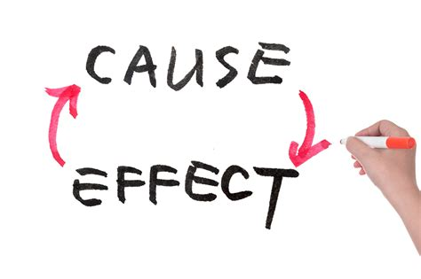

**Summarize- Create a summary in chronological (in order of time) of the most important events of the novel. Be sure to use summarizing tools (S/W/B/S) to plan what you must include and refer to cause and effect.**

**Marking: Writing Strand /10**

|  |  |  |  |  |
| --- | --- | --- | --- | --- |
|  | **Level 1** | **Level 2** | **Level 3** | **Level 4** |
| **Knowledge**  **(S/W/B/S)** | Limited important events | Somewhat uses important events | Mostly uses important events | Expertly uses important events from the novel |
| **Inquiry** | Order of events are unclear | Order of events are somewhat chronological | Order of events are mostly chronological | Order of events are chronological and cause and effect are clear |
| **Communication** | Paragraph format and organization. | Somewhat applies correct paragraph format and organization. | Mostly applies correct paragraph format and organization. | Applies correct paragraph format, organization, spelling, and vocabulary. |

|  |  |  |  |
| --- | --- | --- | --- |
| Somebody | Wanted | But | So |
|  |  |  |  |

Summarize

_______________________________________________________________________________________________________________________________________________________________________________________________________________________________________________________________________________________________________________________________________________________________________________________________________________________________________________________________________________________________________________________________________________________________________________________________________________________________________________________________________________________________________________________________________________________________________________________________________________________________________________________________________________________________________________________________________________________________________________________________________________________________________________________________________________________________________________________________________________________________________________________________________________________________________________________________________________________________________________________________________________________________________________________________________________________________________________________________________________________________________________________