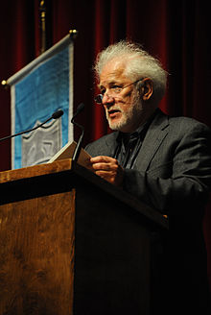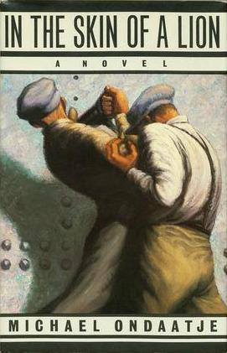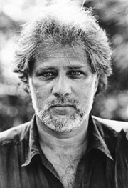

**Michael Ondaatje: Brief Bio**

**Early Life and Education**

Ondaatje was born in [Colombo](http://en.wikipedia.org/wiki/Colombo), Sri Lanka in 1943 and moved to England in 1954 when he was 11. After relocating to Canada in 1962 (19 years old), Ondaatje became a Canadian citizen. He studied for a time at Bishop’s College in [Quebec](http://en.wikipedia.org/wiki/Quebec), but moved to [Toronto](http://en.wikipedia.org/wiki/Toronto), where he received his BA from the [University of Toronto](http://en.wikipedia.org/wiki/University_of_Toronto) and his MA from [Queen's University, Kingston](http://en.wikipedia.org/wiki/Queen%27s_University,_Kingston), [Ontario](http://en.wikipedia.org/wiki/Ontario). He then began teaching at the [University of Western Ontario](http://en.wikipedia.org/wiki/University_of_Western_Ontario) in [London](http://en.wikipedia.org/wiki/London,_Ontario). In 1970, he settled in [Toronto](http://en.wikipedia.org/wiki/Toronto) and, from 1971 to 1990, taught English literature at [York University](http://en.wikipedia.org/wiki/York_University) and [Glendon College](http://en.wikipedia.org/wiki/Glendon_College).

**Work**

Ondaatje's work includes fiction, autobiography, poetry and film. He has published 13 books of poetry, and won the [Governor General's Award](http://en.wikipedia.org/wiki/Governor_General%27s_Award). He has also won the [Booker Prize](http://en.wikipedia.org/wiki/Booker_Prize) for his novel [*The English Patient*](http://en.wikipedia.org/wiki/The_English_Patient), which was adapted into an [Academy Award](http://en.wikipedia.org/wiki/Academy_Awards)-winning film.

**Personal Life**

Ondaatje has two children with wife, novelist and academic, [Linda Spalding](http://en.wikipedia.org/wiki/Linda_Spalding).

1. Sad Daughter
2. Describe the moment that strikes you the hardest.
3. Why does this moment stay with you?
4. List the sense (taste, touch, smell, hear, see) that is most activated by this poem, and find moments in this poem that activate it.
5. How does this poem reverse typical gender roles?
6. What does this poem tell you about Ondaatje?
7. Bear Hug
8. What is the central moment of this poem?
9. How long is the time span of this entire poem, central moment? (approx seconds, minutes, hours)
10. How does this poem make you feel? Why?
11. Tropical Gossip
12. What does this essay tell us about Ondaatje’s family?
13. Does that surprise you?
14. What moment remains with you when you are done reading this essay?
15. What does this moment tell us about Ondaatje’s values?
16. **Write 1/2 -3/4 of a page** **about one moment** that took **less than a minute**. Do not be too personal because you will be asked to share it with the class.
17. In 2 sentences explain what this moment reveals about you or the person it describes
18. Share the moment and they should add what they think it reveals.