Media Presentation: (Oral)
Name: Date:

Criteria | Assessment | Notes/Comments
Knowledge/Understanding
• presentation focused around a clear central idea or purpose | 0 1 2 3 4
• content is accurate, relevant, and complete | 0 1 2 3 4
Thinking/Inquiry
• incorporates logical analysis, generalizations, and conclusions | 0 1 2 3 4
• shows creativity and originality that engages the audience | 0 1 2 3 4
Communication
• organizes material logically | 0 1 2 3 4
• shows a sense of audience and purpose | 0 1 2 3 4
Application
• speaks clearly and audibly delivers presentation smoothly; presenter appears relaxed and at ease (e.g., well rehearsed) | 0 1 2 3 4
• uses appropriate gestures and body language | 0 1 2 3 4
• uses correct language and grammar | 0 1 2 3 4

Media Presentation: Visual (Media)

Criteria | Assessment | Notes/Comments
Knowledge/Understanding
• offers some depth, complexity, and/or sophistication in message | 0 1 2 3 4
• enhances the message with relevant images (and words) | 0 1 2 3 4
Thinking/Inquiry
• engages the viewer with creativity and originality | 0 1 2 3 4
Communication
• choice of images and words show a sense of audience and purpose | 0 1 2 3 4
• selection and juxtaposition of images and words show understanding of elements of design (e.g., line, shape, form, texture, colour, space, tone) | 0 1 2 3 4
• material is organized with attention to visual elements (e.g., balance, contrast, emphasis, movement, patterns, unity) | 0 1 2 3 4
Application
• tools and techniques of the media are used effectively | 0 1 2 3 4

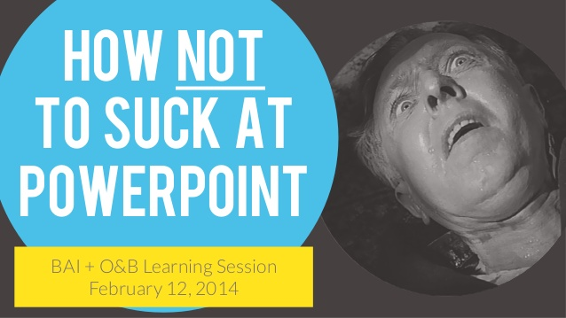

Final Step: Make a prezi or powerpoint that you will present to me to showcase your argument for Adnan Syed!

Tips for success: (Rephrased from the rubric)

- You should have ONE large message or purpose or theme. This message should be made clear in your intro, body, and conclusion of your presentation. Ex. Guilty or Innocent. Choose a side and stick to it.

- Your media presentation should feature images on every screen/ slide. The images all support your words and somewhat entertain your audience. People do not want to read your script, so do not write out what you want to say on the slides. I suggest that you use ONE modern, clear, bright image on each slide with minimal or no words.

- You may choose to have a printed script. But, you should not look on the screen during the presentation. Rather, your focus (eyes and posture) should be towards the audience. The script should not be a copy of your essay, as we speak differently than we write.

- Your presentation should be formal. So use your best words, dress your best, and bring your positive energy.

