What is the most important word in
Leslie’s Journal?

Writing Due Date: ________________________

Presentation Date: ________________________

Step 1. Summarize Leslie’s Journal.

Somebody | Wanted | But | So

Step 2. Provide 3 possible words and a reason for that choice. Circle your final word choice.

Word:  Ex. Divorce | Why/ Reason:  Ex. Leslie’s parents’ divorce made her angry and caused her to acting out at school. That made Jason target her and made her think no one would trust her side of the story.
1.
2.
3.

Step 3. Explain (list evidence) how your word is important for characters, conflict, plot, and setting on large chart paper.

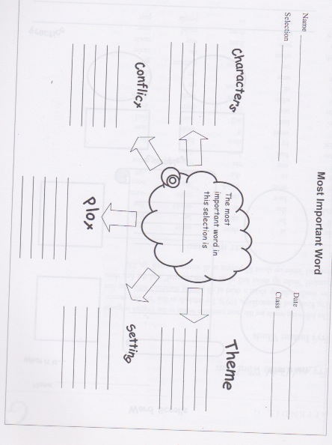
Step 4: Using your word as a starting point, write one theme sentence for Leslie’s Journal.

Definition: Theme is the author’s opinion on your main word. Theme should be an opinion and people should be able to debate the theme statement.

Example of theme: Divorce causes teens to rebel against authority.

Theme is not a moral (an instruction).
-EX. NOT theme “Don’t get divorced.”

Theme is not a cliché (something you have heard many times).
-EX. NOT theme “Stay together for the kids.”

Step 5: Please present to the class using beautiful posture, eye contact, hand gestures, and evidence for your choice.

Rubric:

Communication - The conveying of meaning through various forms
 | 0-49 |  |  | 50-59 | 60-69 |  |  | 70-79 |  | 80-100
Words are audible, and organized.
Uses appropriate non-verbal hand gestures.
Posture is tall (shoulders back) forward facing, engaging, makes eye contact. Expand into space.
Application - The use of knowledge and skills to make connections within and between various contexts
(Theme is not a moral, a cliché, and is debatable)
Theme is supported by specifics from the Novel

Late y/n

Please work on ______________________ by ___________________________

Comments:

Final Mark:

