Categories | 50-59%  (Level 1) | 60-69%  (Level 2) | 70-79%  (Level 3) | 80-100%  (Level 4)
Knowledge and Understanding - Subject-specific content acquired in each course (knowledge), and the comprehension of its meaning and significance (understanding)
 | The student:
Understanding of content  Narration, tone, motifs, themes, characters figurative language echo and build on inspiration piece. | demonstrates limited understanding of content from original text. | demonstrates some understanding of content from original text. | demonstrates considerable understanding of content from original text. | demonstrates thorough and insightful understanding of content from original text.
Thinking - The use of critical and creative thinking skills and/or processes
 | The student:
Use of planning skills  (e.g., genre chart, rough work, process points) | uses planning skills with limited effectiveness in creating genre chart rough work, process points. | uses planning skills with moderate effectiveness in creating genre chart rough work, process points. | uses planning skills with considerable effectiveness in creating genre chart rough work, process points. | uses planning skills with a high degree of effectiveness in creating genre chart, rough work, process points.
Communication - The conveying of meaning through various forms
 | The student:
Use of conventions (e.g., grammar, spelling, punctuation, usage), | uses conventions, vocabulary, and terminology of the discipline with limited effectiveness | uses conventions, vocabulary, and terminology of the discipline with some effectiveness | uses conventions, vocabulary, and terminology of the discipline with considerable effectiveness | uses conventions, vocabulary, and terminology of the discipline with a high degree of effectiveness
Application - The use of knowledge and skills to make connections within and between various contexts
 | The student:
Application of your own creative use of unique horror genre motifs/ theme/ setting/ character/ mood/ etc.  You have frightened me! | applies knowledge and skills in familiar contexts with limited effectiveness | applies knowledge and skills in familiar contexts with some effectiveness | applies knowledge and skills in familiar contexts with considerable effectiveness | applies knowledge and skills in familiar contexts with a high degree of effectiveness

Horror Assignment Sheet and Rubric

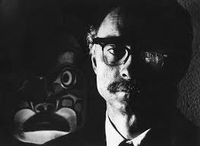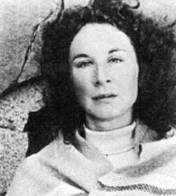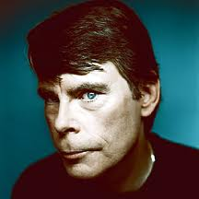

Your task is to create your own horror short story (2 pages double spaced font size 12) that either continues one of the horror stories/ poems/ videos that we watched OR that creates an alternate ending.

Horror Genre Generating Sheet: ______________________________
Peer Edit Date: ______________________________
Due Date: ______________________________

- You may not contradict content from your inspiration piece
- You must build and develop your own horror in line with general horror conventions AND your inspiration piece.
- You must complete the horror Genre generating chart
- You must complete rough copies on time for peer editing days
- You must be creative (introduce new items that were not there before) to shock and frighten your reader
- You must complete the reflection piece assigned on the due date.

