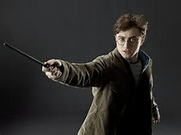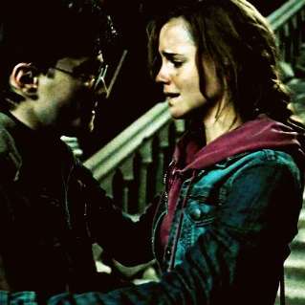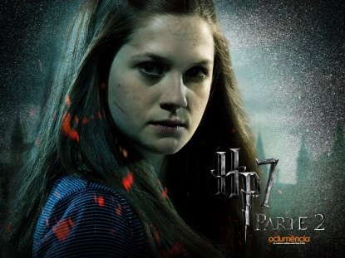

1. Of all the things that Harry's Uncle Vernon said to Hagrid, what was the thing that upset him the most?

Uncle Vernon said they'd stomp it (magic) out of him (Harry).
Uncle Vernon told Harry that his parents died in a car crash.
Uncle Vernon called Dumbledore 'some crackpot old fool'.
Uncle Vernon called Harry's parents weirdos.

2. What was unusual about the school song that Dumbledore led everyone in singing after the Sorting Feast?

Each house sang different words.
The ghosts danced together while the song was being sung.
The professors sang different words from the students.
Everyone sang it to their own favourite tune.

3. Whose actions were accidentally responsible for Harry's ultimately being named Seeker to his house's Quidditch team?

Hermione Granger
Harry's father
Professor Dumbledore
Draco Malfoy

4. What flavour of 'Bertie Bott's Every Flavour Bean' did Dumbledore end up with?

Toffee
Earwax
Peppermint
Vomit

5. When did Hermione really become friends with Harry and Ron?

After they found Fluffy guarding the trap door.
After they saved her from the troll.
After she saved Harry from falling off of his broom in the first Quidditch match.
After Harry stood up to Malfoy and saved Neville's Remembrall.

6. What was Harry's Christmas present from his Aunt Petunia and Uncle Vernon?

A fifty-pence piece.
A tissue.
An old pair of socks.
An old sweater of Dudley's.

7. Harry sees only his mother and father in the Mirror of Erised.

True
False

8. When asked what he saw when he looked into the mirror, Dumbledore said that he saw himself holding a pair of thick, woollen socks.

True
False

9. After months of searching, where did they finally find the name of Nicolas Flamel?

From Professor Binns, in their History of Magic class.
In a book from the Restricted Section of the library.
On the back of a 'Famous Wizard' card from a chocolate frog packet.
In 'Hogwarts, a History'.

10. Who was really trying to steal the stone?

Snape
Quirrell
Lupin
Filch
11. Where was Ron when Harry and Hermione took Hagrid's dragon to the tallest tower in the castle so that Charlie Weasley's friends could transport it to Romania?

Serving detention with Filch for being caught out of bed.
Keeping watch in case Malfoy came along and tried to get them in trouble.
Keeping Hagrid company so that he wouldn't be too sad about losing his dragon.
In hospital, recovering from a dragon bite.

12. When Voldemort, feeling stronger from drinking unicorn blood, tried to attack Harry in the Dark Forest, who saved him?

Hermione and Neville.
Firenze - a centaur.
Hagrid.
Draco and Fang.

13. What convinced the friends that Snape (or so they believed) was going to try and get the stone that very night?

Professor Dumbledore had been summoned away from Hogwarts.
Hagrid let slip that Snape was one of the professors guarding the stone.
Hagrid had let slip the secret of how to get past Fluffy to a stranger in the pub.
Harry overheard Quirrell being threatened by Snape.

14. Of the many things guarding the stone, what was the only one that Quirrell/Voldemort could not figure out or overcome?

The Mirror of Erised.
The Riddle of the Potions.
The Wizard's Chess Game.
The Devil's Snare.

15. What present did Hagrid give Harry when he came to visit him in the hospital wing? (This is how it happened in the book, not in the movie.)

A photo album filled with pictures of his parents.
A new broomstick.
The book, 'Quidditch Through the Ages'.
A book of spells to use on Dudley.

Long Answer Questions
Evidence and opinion:
- In your opinion, what is the most important thing that Harry learns from Hogwarts? Explain what makes this important and use examples from the novel. (Consider: love, friendship, value of self)

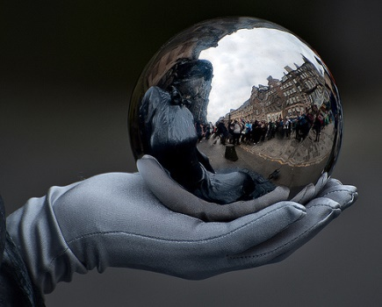

- Predict and imagine what events might happen at the end of the Harry Potter Series? Ex. Might someone die? Who? Who might get married and why do you think this?

- What magic would you perform if you were at Hogwarts?

Draw a picture from the scariest moment of the novel.

Draw a picture from the happiest moment of the novel.

