Essay Rubric

 | N | R | S | C | M
Knowledge/Understanding /5
Displays knowledge of texts
Displays knowledge of deep viewing terms
Thesis is clear and argued throughout
Thinking/Inquiry /10
Critical and insightful observations (exploration beyond the obvious)
Use of relevant, direct quotations that effectively support information
Use of varied diction
lead and conclusion are both creative
Creative title and hook
Cohesion throughout (ideas run smoothly into the next)
Communication /10
Effective thesis statement (organized and clear)
Effective topic sentences
Arguments organized
Quotations are integrated in an organic fashion
Conclusion restates the thesis with appropriate footprints that do not introduce new material to the essay
No use of first or second person
Formal diction -- no slang/colloquial language
Active voice
Present tense
Proper grammar (commas, capitals, complete sentences)
Proper spelling throughout
Application /5
MLA format is used throughout (header, double space, page top right)
Works Cited accompanies the essay
Quotations are cited properly (Lastname page)
Evidence of careful editing (all rocess attached)

TOTAL /30
Comments:

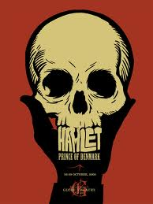

Your Task:

-Plan and write an in-class, persuasive, thematic essay for Hamlet.

-As evidence, use a combination of deep viewing and direct quotations.

Questions:

1. Are women naturally weak?

2. Is acting evil because it is a lie?

3. Does any position of power, including the role of parent, lord, lover, corrupt a person?

4. Is murder ever justified?

5. What makes a person insane?

