Grade 11 University Comparison Essay

 | N  0-49 | R  50-59 | S  60-69 | C  70-79 | M  80-100
Knowledge/Understanding
/10
Basic MLA formatting is followed: double spaced, header, page number, indented paragraphs, 5 distinct paragraphs.
Works Cited accompanies the essay: no numbers, alpha order, correct indents and punctuation, titles underlined, chapters in quotes.
Process fulfilled as directed and in order: 1. rubric, 2. good, 3. peer edit, 4. rough work, 5. Plans, 6. Reflection
Introduction format order: Hook, author/title sentence, thesis, directional statement
Body paragraphs order: Topic sentence, organization, quote/ link (x3) or (x6) (ABABAB format in comparison).
Quotations are cited and formatted properly: EX.
Sylvia targets the boy she “hate[s]… so much” (Reaney 2).
Conclusion restates the thesis with appropriate footprints that do not introduce new material to the essay. Thesis/ directional summarized.
Thinking/Inquiry
/10
Thesis sentence is clear/ unique/ strong/ engaging
Relevant and insightful evidence. Direct quotes used. (3 minimum in basic. 6 minimum in comparison paragraph)
Links from evidence to thesis are clear. Limited plot.
Organization—Three points per paragraph are introduced in Topic Sentence. Order is logical and clear. Transition words help flow and clarity.
Communication
/10
Quotations are integrated in an organic fashion with your sentences. They follow all formal essay rules.
No use of first person. (I, me, you, us, we, thee, thou, thy)
Formal words -- no slang or contractions (can’t, won’t, he’s)
Present tense.
Clarity/ Grammar/ spelling/ (especially grammar sheet items)

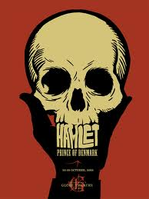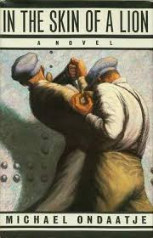

Questions

Throughout your 5 paragraph essay, create a unique thesis to answer ONE of these questions. Use a maximum of TWO of these works: Hamlet , In the Skin of a Lion, or your book club novel.

1. Is it possible to be isolated among friends?

2. Are words necessary for understanding?

3. What must children learn from their parents?

4. Does coming of age guarantee intelligence?

5. Does the fittest human always survive?

6. What makes a human cruel OR what makes a human kind?

7. Is romantic love the most important part of life?

Create your own, but run it by me please.

