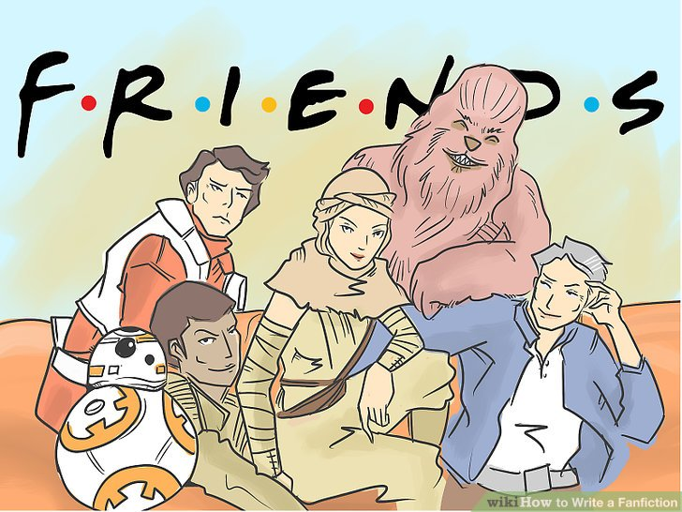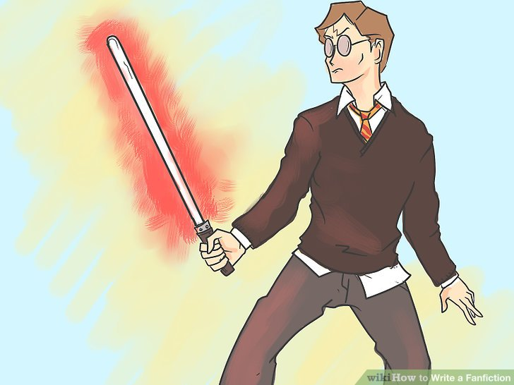

Tasks and Due Dates

Part A: | Research your starting point/s | Due Dates
Part B: | Create one chapter (1,000 words OR 3-4 pages)
Part C: | Write Author Notes
Part D: | Write a Summary for your fanfiction
Part E: | Re-read your work
Part F: | Publish on a fanfiction website (optional)
Part G: | Accessorize your story with fitting songs or drawings

What is Fan Fiction?

It is a form of alternate or expanded universe created by the fans of a work, rather than the work's original creator. Fan Fiction, or "Fanfics" as they are often called, are written for any number of reasons:
- to continue a story that ended prematurely (Continuation Fic);
- to redo a story the way the author thinks it should have gone (see Fix Fic);
- to see what would happen if certain characters are placed in unusual situations (see Alternate Universe Fic),
- to see what happens when the characters of one franchise encounter the characters of another franchise (see Crossover);
- to imagine oneself in the fictional universe (see Self-Insert Fic);
- to get the characters to date, marry, have children with, or have crushes on, each other or the author (see Shipping)

Expert Advice on the Genre and Typical Paratext of Fanfiction:

- Do your research before writing.
Expert fanfiction writer says, “Take a minute to google stuff you don't know.” I suggest that you pick a premise that you have thoroughly read—maybe more than once. “Seriously, it infuriates me when I read a story where everything about it is wrong. This also applies to actual concepts, like the concept and procedure of total war.”

- The task is to create one chapter inspired by an existing and well known story.
The chapter should be around 1,000 words or 3-4 pages of font 12, double spaced writing.

- Provide brief Author Notes.
Expert fanfiction writer says, “I consider that cheating with your word count if you explain too much in your author notes” Perhaps stick to one short paragraph or 3-5 sentences for Author Notes. “Look, I understand you want to speak to your readers, answer their questions, be cheeky, and all that. However, if it drags on to take up a large portion of the chapter, I don't consider it a good thing. And if you have to explain something to a reader then you've probably done something wrong in your narrative, as your story should the one explaining things, and not the author.”

- Provide a brief summary at the start of your story.
Expert fanfiction writer says, “Don't write 'I suck at summaries' in your description. Same goes for 'full description inside.' Look, if you don't have confidence in giving a short description of what your story is, then what faith can I give you in write a story that is would interest me?

- Don't reveal (in author notes or the summary--paratext) what your plans for romantic or antagonistic pairings are.
Fanfiction expert says, “If your story is about the Mass Effect universe being integrated with Spiral Powers, then don't tell me that Kamina and Liara are going to hook up in the description, that sucks the fun out of it, and could turn me off from reading it. How would Harry Potter fare if right from the start, J.K. Rowling said Ron and Hermione are going to get together in the end? It ruins the drama, as we know the two are going to be together in the end, and it ruins the fun of guessing and ‘shipping.”

- You need to transition the medium you chose (video game/ movie) into a writing medium.
This is mostly comes from reading video game terms and logic in a story, which is a can of worms for me. Description of leveling up, and descriptions of how much damage and accuracy a weapon has, along with Health Points. It a weird thing that turns me off, and I hope I'm explaining this right.

- No OCs [Original Characters] as protagonists.
Fanfiction expert says, “This one is really a very personal preference of mine. I'm fine with O.C.s being supporting characters, or even sharing the spotlight, that's fine. However, one thing I hate most in fanfiction is an OC being given the main spotlight. One of the reasons I read fanfiction in the first place is to read about these character I know and like being put in different situations. I know who they are, what they look like, and why they do what they do. I wanted to learn all that from an original character then I'll go read an actual book.”

- Reread your stories—A LOT.
Words from an expert, “I know this is fanfiction and grammar isn't exactly high on the priority list, but for heaven’s sakes, have some class. Every time I read my story, I always find some sort of error involving grammar, odd wording, missing words, or something else that is inconsistent. After re-reading, I can make the appropriate corrections, and replace the original chapter, which is easy on fanfiction.net.”

More background information on the History of the Genre
History:
Although fanfic exploded along with the Internet, it existed well before the Net did. Such luminaries as John Stuart Mill contributed unauthorized, original stories set in a fictional universe. Before medieval French troubadours were shipping Launcelot and Guinevere, the ancient Greeks were writing plays about relationships between characters in The Iliad.
Form:
Not all fanfic is written, though that's the most common form. It can be in any format that can tell a story. In Japan, doujinshi (amateur "comic books") are a common vehicle of fanfiction; and with the increasing ease of their production on personal computers, fan videos (ranging from anime series, to Star Wars) have already appeared.

“Fanfic.” TV Tropes, tvtropes.org/pmwiki/pmwiki.php/Main/FanFic.

Deconstructed Fanficts
 | Level 1 | Level 2 | Level 3 | Level 4
Knowledge:  Pick an existing story (from ANYWHERE!: videogame, old wives’ tale, history, TV, YouTube) that you already know well. List main character traits to stay consistent. | Knowledge of the inspiration piece/s is unclear. | Knowledge of the inspiration piece/s is somewhat established and clear. You are consistent with essential character traits. | Knowledge of the inspiration piece/s is established and mostly clear. You are consistent with essential character traits. | Knowledge of the inspiration piece/s is established and very clear. You are consistent with essential character traits.
Inquiry:  Avoid clichés  - It was a dream  -It was a fantasy | You are not creative in your own story. | You are somewhat creative in your own story. There is some unique interaction of existing characters and storylines. | You are creative in your own story. There is a unique interaction of existing characters and storylines. | You are highly creative in your own story. There is a unique interaction of existing characters and storylines.
De-construction  Add ONE clear layer of critique from a POV:  Feminist, Marxist, archetypical, post colonialism, new historicism, psycho analytical | You have not added a layer of critical lens to your piece. | You use a somewhat consistently critical lens that adds a vital layer of interest to your piece. | You use a mostly consistent critical lens that adds a vital layer of interest to your piece. | You use a consistently critical lens (ONE) that adds a vital layer of interest to your piece.
Application: No OCs as protagonists, transition medium, don’t reveal in author notes, summary | The guidelines established are followed to a limited extent. | You apply some of the guidelines established of a typical fanfiction text. | You apply most of the guidelines established of a typical fanfiction text. | You apply all of the guidelines established of a typical fanfiction text.
Communication:  Fanfiction does not have to be FORMAL writing, but it does have to make sense. | Your story does not make sense. I can’t follow. | Your grammar, timeline, and spelling are somewhat clear. | Your grammar, timeline, and spelling are mostly clear. | Your grammar, timeline, and spelling are clear.

Other Notes: ___________________________________________________________

