Facts about _________________ by ___________________
Animal Report
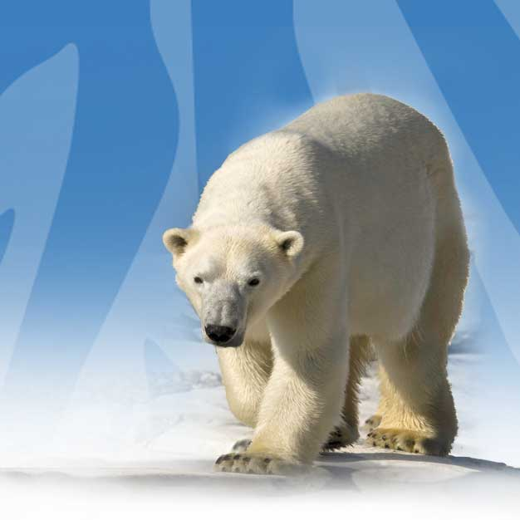
Task description:
- This is a research project. You should review search terms and reliable sources before you start.

- Every question should answer with a minimum of 3 full sentences.

- If it is an image, you should colour it and label it with 5-6 labels

- Draw this animal in detail in the space provided. Use full colour and label 5-6 distinctive parts.

- Where is this animal found? What environment/ climate/ features are important to their survival?

- What does your animal eat?
- How do they gather their food?
- How do they eat?
Describe in detail AND draw a diagram:

AND

- Describe how they care for their young? AND Describe how they groom each other?

- How does your animal impress his or her mate? Do they stay together? Do they have many mates?

(Answer Question 6 or 7)
- Can this animal ever help humans? Explain how.
OR
- Is this animal EVER a pet for humans? If so, what would the owner require for its care?

- Where and when does your animal sleep?

- What is something else that you learned about your animal that others should know?

List your sources you used to answer the questions above:

Website

Title of article

Date updated

Name of Author

Website

Title of article

Date updated

Name of Author

Website

Title of article

Date updated

Name of Author

