Design a Picture Book
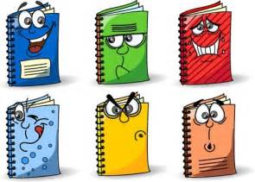
Your Choices:
- Write a story for young children
- Write a recipe book
- Write a book of your travels (near and far)
- Write a story of your life so far
- Write a summary of activities available at Bloorview
- Make a collection of your favorite songs
Requirements: You must have
- 10-12 pages long (minimum)
- 5-8 images (minimum) (draw or find online)
- 3-5 sentence of your own writing on every page
  - Cover
  - Index/ Table of contents
  - About the Author page

