Descriptive Writing:

Sensory Details:
Create a “bank” of words to describe some of these sensory details:
- Sight – ex: colours, shapes, sizes, patterns, etc…
- Sound – ex: loud or soft, harmonious or harsh, pleasant or unpleasant, etc…
- Smell – ex: sweet or sour, pleasant or unpleasant, aromatic or stinky, etc…
- Taste – ex: sweet, bitter, burning, spicy, bland, etc…
- Touch – ex: hard, soft, rough, smooth, hot, cold, dry, oily, etc...

References:
Create a “bank” of words to describe some of these references:
- People – ex: height, body type, hair, features, etc…
- Places – ex: features, temperatures, business, etc…
- Objects – ex: colour, texture, shape, etc…

Try it:
A description of: | Three sentences | The senses used
A member of your family | 1.  2.  3.
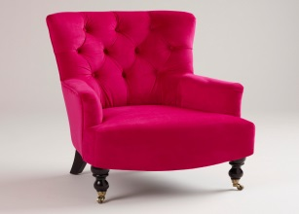 | 1.  2.  3.
Your own room | 1.  2.  3.
1.

2.

3.

