Decisions

by only1rob
November 22, 2010
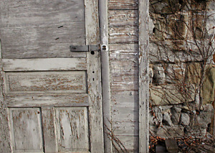
“So what should we do?”
“We should just leave her, close the door and walk away.”
“NO! That’s what got us here in the first place! We have to do the right thing.”
“Which is?”
“Maybe we can cure her?”
“Cure her? Really? Are we looking at the same person? Never mind the devastation going on out there, but she can’t be cured. Her arm is practically hanging off at the shoulder and her guts are still in the other room.”
“Well, we can’t just leave her here, maybe we could bring her with us? Get away from the city and find someone to help?”
“…”
“OK, maybe we get her some food, some water and then come check on her later on?”
“We are her food, you idiot. Go grab the axe so we can be done with it.”
“No!”
“We have to, the handcuff won’t hold someone in her condition for long. Either get the axe or get the door.”
“I can’t, it’s not right. She is a person.”
“Was a person you mean. She’s just like the ones out there. You didn’t have a problem taking the axe to all of them, did you? How many of those ‘people’ did you kill? There must have been easily fifty, maybe more.”
“They weren’t people, they wanted to kill me. To eeeeat me. To turn me into one of them.”
“Just like she does.”
“You’re wrong.”
“Then why is she handcuffed?”
“Because…”
“Exactly, now get the axe before she rips her shoulder apart.”
“…”
“Do it”
“I shouldn’t listen to you, you’re bad for me! Get out of my head! GET OUT!”
“I’m the only thing keeping us alive. Now do it! DO IT!”
“I… I’m sorry Mom. I love you.”

