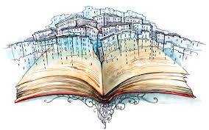
Creative Writing Task
Rough and printed copy due (peer edit date):
Due Date:

- Your task is to thoroughly plan and write a story that is 2-3 pages long double spaced.

- You must use your best grammar, particularly lessons on dialogue

- It must have a clear and creative theme, plot, conflict, narrative voice, and you must use literary devices such as metaphor, simile, alliteration appropriately

- You must partake in all parts of process

- A) Planning

- B) Rough Draft

- C) Peer edit

- D) Self edit and reflect

This mark will be recorded under the Writing Strand

