Create a Short Graphic Scene
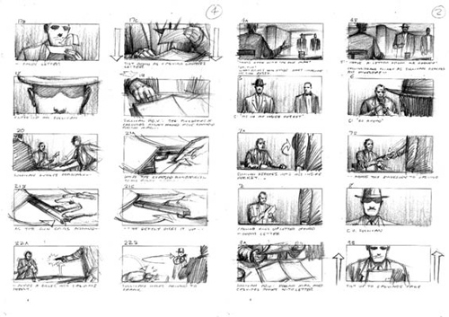
Task: Create an engaging graphic scene (5-10 panels or one page) about a character from your graphic novel or comic.
Option 1: Your short scene starts before the novel
Option 2: Your short scene takes place after the novel
Option 3: Detail an event that happened off the page of the existing novel
You may | You may not
-Introduce new characters  -Continue to develop existing characters  -Introduce a new detail  -Be funny, sad, mysterious, interesting | -Have an existing character do something against their personality  -Contradict events of the plot in the established story

Possible Tools:
-Comic life
-Bitstrips
-Makebeliefscomix
-Toondoo
-Storyboardthat
-Pixton
-Strip generator
Suggested Steps:
Step 1: Brainstorm your scene
Step 2: Complete a story board (rough draft) or visual rough plan
Step 3: Investigate the various comic strip generating online tools and get to know which one works for you.
- Your teacher is NOT responsible for lost work or for troubleshooting, so take the time now to ensure it will work. At the end of the day, you may submit hand drawn materials, so don’t blame technology.
- At the time the list was made these tools were free. Please do not spend your money on this task. Pick a different comic strip generator or hand draw it.
Step 4: Create your own good copy graphic scene online. Be original but show me what you know.
Step 5: Print out your hard copy and hand it to your teacher. Include all of your process.

Student Name:

 | Level 1 | Level 2 | Level 3 | Level 4
Knowledge | Conventions (thought bubbles, transitions, font, gutter etc) of graphic are missing or unclear. | Conventions (thought bubbles, transitions, font, gutter etc) of graphic are somewhat applied. | Conventions (thought bubbles, transitions, font, gutter etc) of graphic are mostly applied. | Conventions (thought bubbles, transitions, font, gutter etc) of graphic are applied with sophistication
Knowledge | Characters are contradicted or unclear. | Characters are somewhat identifiable by their actions and dialogue. | Characters are mostly identifiable by their actions and dialogue. | Characters are always identifiable by their actions and dialogue.
Inquiry | The comic repeats novel. | The comic is very somewhat creative. | The comic is mostly creative. | The comic is very creative. Many original ideas.
Communication | Messy work makes reading difficult. | Scene is somewhat easy to follow, Lettering is neat and legible. | Scene is mostly easy to follow, Lettering is neat and legible. Space is used well. | Scene is easy to follow, Lettering is neat and legible. Space is used well.
Application | No rough work provided.  Grammar, punctuation, and spelling make understanding difficult. | Final product is a somewhat improved production of the original draft.  In captions, grammar, spelling, and punctuation and only uses slang somewhat appropriate to the character. | Final product is an improved production of the original draft.  In captions, grammar, spelling, and punctuation and only uses mostly slang when appropriate to the character. | Final product is an excellent production of the original draft.  In captions and speech bubbles, grammar, spelling, and punctuation and only uses slang when appropriate to the character.

Rough storyboard: Planning Option
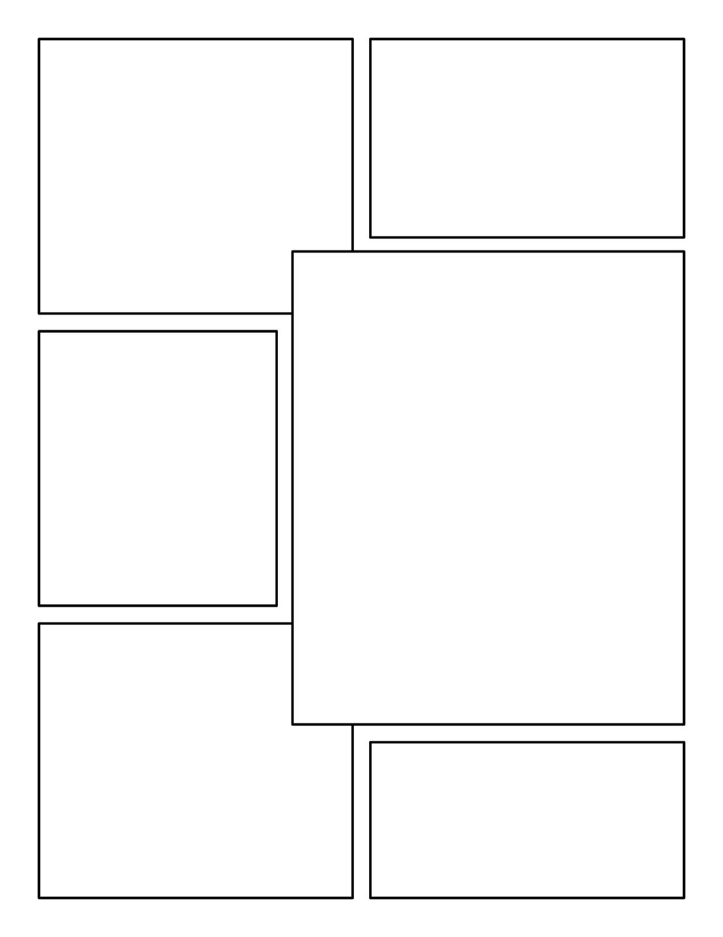
Plot Terms: Planning Option

