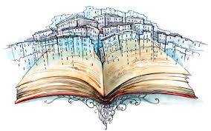
Creative Writing Task
Rough and printed copy due (peer edit date):
Due Date:
Storytelling:
- Your task is to thoroughly plan and write a story that is 2-3 pages long double spaced.

- You must use your best grammar, particularly lessons on dialogue

- It must have a clear and creative theme, plot, conflict, narrative voice, and you must use literary devices such as metaphor, simile, alliteration appropriately

- You must partake in all parts of process:

- A) Planning (story mountain, character sheets, etc)

- B) Rough Draft and Peer edit

- D) Good copy= Writing Strand

- D) Self edit and reflect= Reading Strand

- E) View and analyze Storytellers= Media Strand

- D) Perform your story= Oral Communication

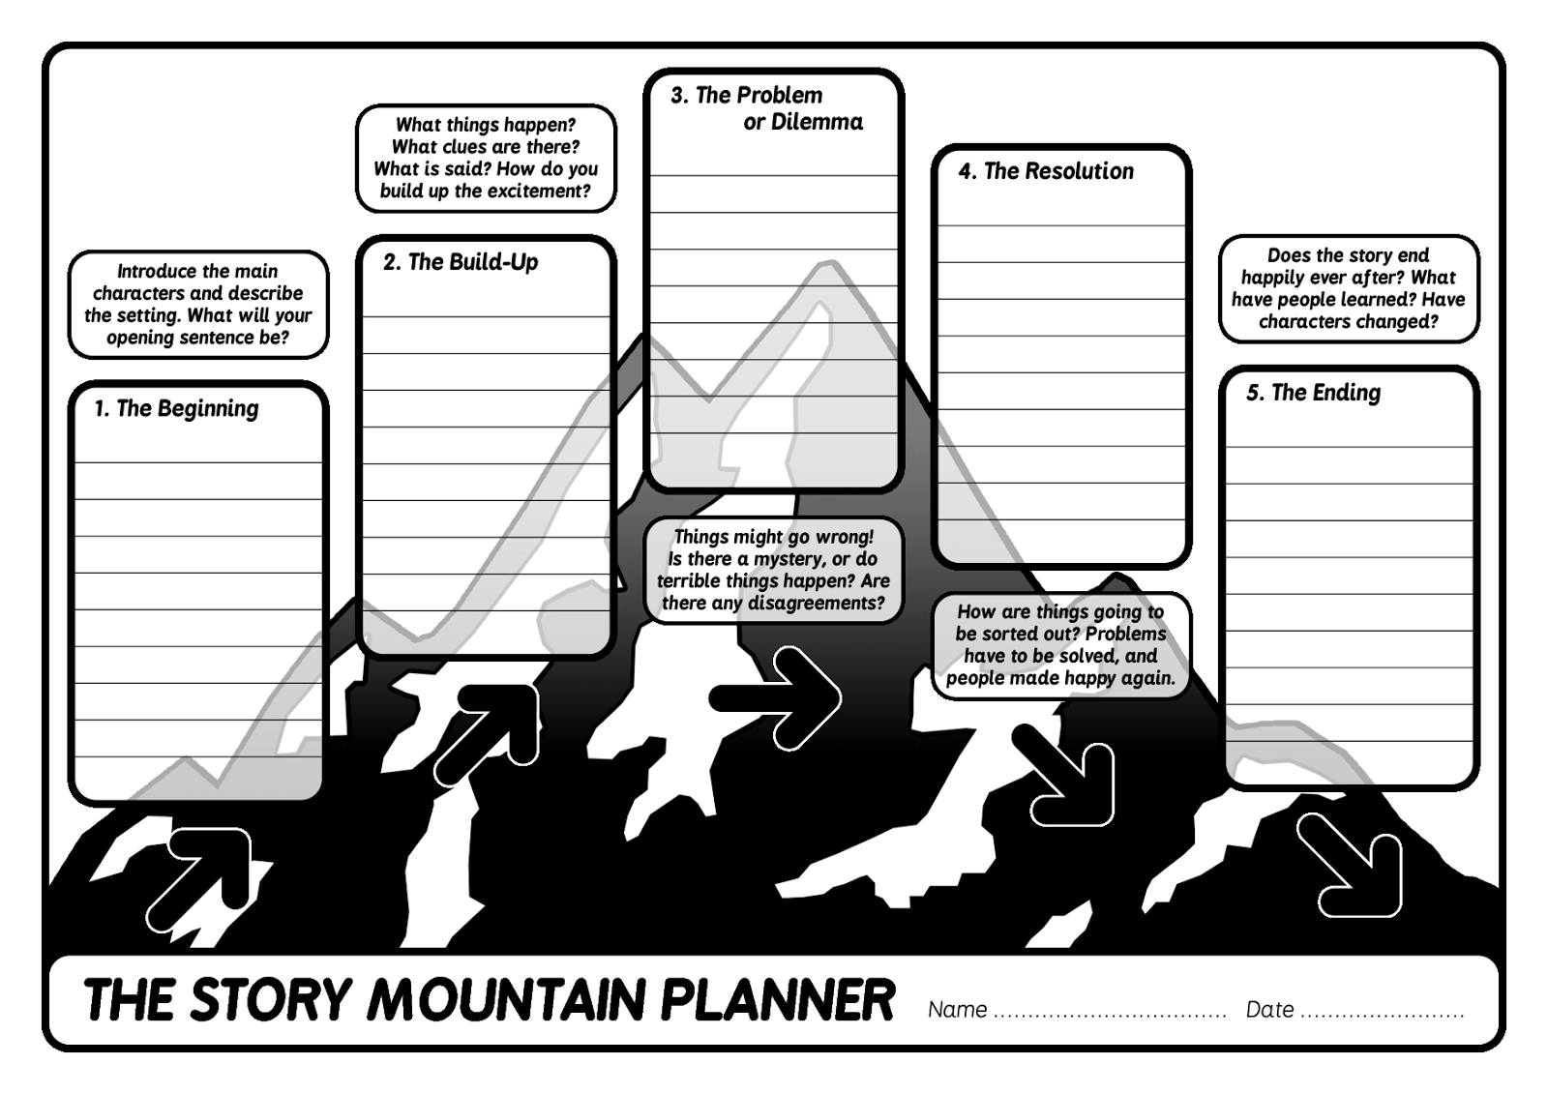
Rubric: Short Story
Student: Task:
Date: Assessor: Peer

Criteria | Level 1 | Level 2 | Level 3 | Level 4
Knowledge/  Understanding  • theme or controlling idea | ❑ incorporates a theme or controlling idea that shows limited thought | ❑ incorporates a theme or controlling idea that shows some thought | ❑ incorporates a theme or controlling idea that shows considerable thought | ❑ incorporates a well-thought-out theme or controlling idea
Thinking/Inquiry  • originality in storyline | ❑ storyline shows limited originality | ❑ storyline shows some originality | ❑ storyline shows considerable originality | ❑ storyline is highly original
• risk taking with literary techniques (e.g., humour, irony) | ❑ takes few risks with literary techniques to create desired impact | ❑ takes some risks with literary techniques to create desired impact | ❑ takes considerable risks with literary techniques to create desired impact | ❑ takes extensive risks with literary techniques to create desired impact
Communication  • command of story structure | ❑ limited effectiveness in introducing the conflict;   passage of time has limited clarity and continuity;   dialogue to develop character and plot is limited;   ending shows little syntactic maturity or control | ❑ shows some effectiveness in introducing the conflict;   passage of time has some clarity and continuity;   dialogue to develop character and plot is somewhat effective;   ending provides a logical resolution and shows some syntactic maturity and control | ❑ shows considerable effectiveness in introducing the conflict;   passage of time has considerable clarity and continuity;   dialogue to develop character and plot is effective;   ending provides an effective and logical resolution and shows considerable syntactic maturity and control | ❑ highly effective in introducing conflict;   passage of time has a high degree of clarity and continuity;   dialogue to develop character and plot is highly effective;   ending provides an effective, complex resolution and shows a high degree of syntactic maturity and control
• style (syntax and word choice) | ❑ word choice has limited variety and vitality | ❑ word choice shows some variety and vitality | ❑ word choice shows considerable variety and vitality | ❑ word choice shows a high degree of variety and vitality
• narrative voice | ❑ narrative voice has limited connection to characters and setting | ❑ narrative voice has some connection to characters and setting | ❑ narrative voice is effective in reflecting characters and setting | ❑ narrative voice is highly effective in reflecting characters and setting
Application  • language conventions | ❑ applies grammar, usage, spelling, and punctuation with limited accuracy and effectiveness | ❑ applies grammar, usage, spelling, and punctuation with some accuracy and effectiveness | ❑ applies grammar, usage, spelling, and punctuation with considerable accuracy | ❑ applies grammar, usage, spelling, and punctuation with a high degree of accuracy
Rubric: Short Story (Writing Strand)
Student: Task:
Date: Assessor: Teacher

Criteria | Level 1 | Level 2 | Level 3 | Level 4
Knowledge/  Understanding  • theme or controlling idea | ❑ incorporates a theme or controlling idea that shows limited thought | ❑ incorporates a theme or controlling idea that shows some thought | ❑ incorporates a theme or controlling idea that shows considerable thought | ❑ incorporates a well-thought-out theme or controlling idea
Thinking/Inquiry  • originality in storyline | ❑ storyline shows limited originality | ❑ storyline shows some originality | ❑ storyline shows considerable originality | ❑ storyline is highly original
• risk taking with literary techniques (e.g., humour, irony) | ❑ takes few risks with literary techniques to create desired impact | ❑ takes some risks with literary techniques to create desired impact | ❑ takes considerable risks with literary techniques to create desired impact | ❑ takes extensive risks with literary techniques to create desired impact
Communication  • command of story structure | ❑ limited effectiveness in introducing the conflict;   passage of time has limited clarity and continuity;   dialogue to develop character and plot is limited;   ending shows little syntactic maturity or control | ❑ shows some effectiveness in introducing the conflict;   passage of time has some clarity and continuity;   dialogue to develop character and plot is somewhat effective;   ending provides a logical resolution and shows some syntactic maturity and control | ❑ shows considerable effectiveness in introducing the conflict;   passage of time has considerable clarity and continuity;   dialogue to develop character and plot is effective;   ending provides an effective and logical resolution and shows considerable syntactic maturity and control | ❑ highly effective in introducing conflict;   passage of time has a high degree of clarity and continuity;   dialogue to develop character and plot is highly effective;   ending provides an effective, complex resolution and shows a high degree of syntactic maturity and control
• style (syntax and word choice) | ❑ word choice has limited variety and vitality | ❑ word choice shows some variety and vitality | ❑ word choice shows considerable variety and vitality | ❑ word choice shows a high degree of variety and vitality
• narrative voice | ❑ narrative voice has limited connection to characters and setting | ❑ narrative voice has some connection to characters and setting | ❑ narrative voice is effective in reflecting characters and setting | ❑ narrative voice is highly effective in reflecting characters and setting
Application  • language conventions | ❑ applies grammar, usage, spelling, and punctuation with limited accuracy and effectiveness | ❑ applies grammar, usage, spelling, and punctuation with some accuracy and effectiveness | ❑ applies grammar, usage, spelling, and punctuation with considerable accuracy | ❑ applies grammar, usage, spelling, and punctuation with a high degree of accuracy
Theme:

The theme of my story is _______________________________________________________________________

The theme is apparent when
_______________________________________________________________________

_______________________________________________________________________

_______________________________________________________________________
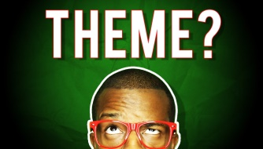
Plot/ conflict:

My story is unique or mature because _______________________________________________________________________

My conflict is _____________________ vs ________________________

I know this because
_______________________________________________________________________

My rising action or climax is exciting because _______________________________________________________________________

My conclusion is satisfying because _______________________________________________________________________
Poetic Literary Devices:
Find examples from your story of
Onomatopoeia____________________________________________________________
Alliteration______________________________________________________________
Metaphor_______________________________________________________________
Simile__________________________________________________________________
Hyperbole_______________________________________________________________
Personification___________________________________________________________
Symbol_________________________________________________________________

How did I experiment or take a chance with devices or my story to make an impact?

_______________________________________________________________________

_______________________________________________________________________
Characterization and Dialogue:
How did the audience get to know my character through dialogue?
_______________________________________________________________________
What is one way your protagonist is imperfect?
_______________________________________________________________________
What is one way your protagonist changes throughout the story?
_______________________________________________________________________
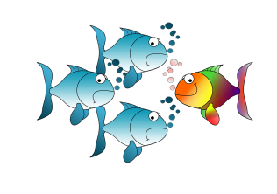
My Narrative Voice:

I used _______________________ POV (first person, omniscient, limited omniscient) because _______________________________________________________________________

_______________________________________________________________________
I learned a new word while I wrote this story. That new word is ___________________

It means _______________________________________________________________

I chose it because ________________________________________________________

Drawing Conclusions (consider: setting, format, tone, mood)
I did a good job with ______________________ because _______________________________________________________________________

I must make changes to ______________________ because _______________________________________________________________________

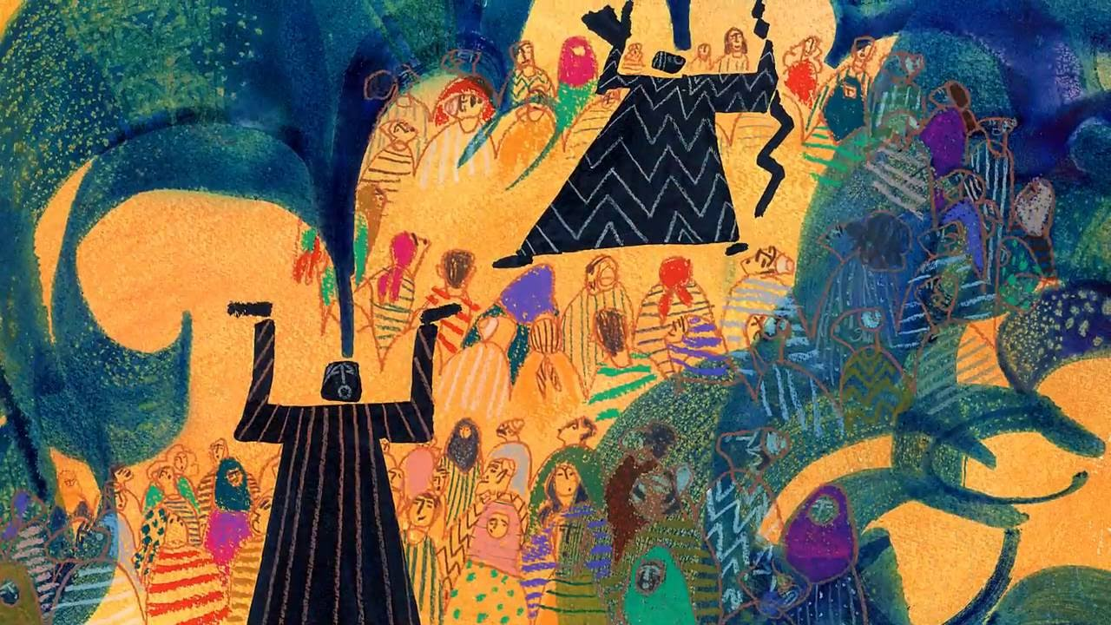
Analysis of Storytellers: The Moth /17 marks (Media Strand)

In all your observations, who is the best speaker? WHY? /2 marks

Who is the worst speaker? WHY? /2 marks

Who is the best story teller? WHY? /2 marks

Is story telling a different skill from speaking? Explain. /2 marks

What aspects (2 min) from your observations would you like to use in your task? WHY? / 3 marks

What aspects will you choose NOT to use or would not work in your format? WHY /2 marks

Is emotion essential to storytelling? EXPLAIN your answer. /2 marks

Is movement or voice more essential to storytelling? Pick a side and explain. /2 marks

Rubric: Story Telling (Oral communication)
Student: Task:
Date: Assessor: Self Peer Teacher

Criteria | Level 1 | Level 2 | Level 3 | Level 4
Knowledge/  Understanding  • understanding of the material | ❑ expression and intonation indicate limited understanding of the material and the speaker/character | ❑ expression and intonation indicate some understanding of the material and the speaker/ character | ❑ expression and intonation indicate considerable understanding of the material and the speaker/character | ❑ expression and intonation indicate thorough and insightful understanding of the material and the speaker/character
Thinking/Inquiry  • creativity | ❑ interpretation shows limited creativity | ❑ interpretation shows some creativity | ❑ interpretation shows considerable creativity | ❑ interpretation shows a high degree of creativity
Communication  • sense of audience and purpose | ❑ shows limited awareness of audience | ❑ shows some awareness of audience | ❑ addresses audience with considerable confidence | ❑ addresses audience with a high degree of confidence
Application  • voice | ❑ voice has limited clarity | ❑ voice is moderately clear | ❑ voice is clear and appropriate | ❑ voice is clear and highly effective
• body language | ❑ shows limited command of gestures and body language | ❑ shows some command of gestures and body language | ❑ shows considerable command of gestures and body language | ❑ shows strong command of gestures and body language
• reading (accuracy/ pronunciation) | ❑ reads with limited accuracy and effectiveness | ❑ reads with some accuracy and effectiveness | ❑ reads with considerable accuracy and effectiveness | ❑ reads with a high degree of accuracy and effectiveness

