Grade 11 University Comparison Essay

 | N | R | S | C | M
Knowledge/Understanding /5
Displays knowledge of both texts
Evenly distributes information in both stories
Thesis is clear and argued throughout
Thinking/Inquiry /10
Critical and insightful observations (exploration beyond the obvious)
Use of direct quotations that effectively support information
Use of formal and varied diction
lead and conclusion are both creative
Creative title and hook
Cohesion throughout (ideas run smoothly into the next)
Texts are linked through comparison and contrast throughout the essay.
Communication /10
Effective thesis statement (organized and clear)
Effective topic sentences
Arguments organized in an ABABAB format
Quotations are integrated in an organic fashion
Conclusion restates the thesis with appropriate footprints that do not introduce new material to the essay
No use of first or second person
Formal diction -- no slang/colloquial language (unless in a quotation)
Active voice and present tense
Proper grammar and spelling
Application /5
MLA format is used throughout (header, double space, page number top right)
Works Cited accompanies the essay
Quotations are cited properly
Evidence of careful editing (rough work, notes, brainstorming)

TOTAL /30
Comments:

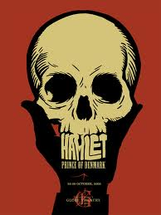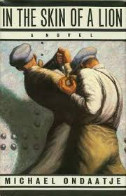

Questions

Using Hamlet and In the Skin of a Lion, please answer:

1. Is it possible to be a foreigner in one’s own home?

2. Is language necessary or even helpful for communication?

3. What must children learn from their parents?

4. How does a past (lover, parents, education) haunt a person’s future?

5. Does acting help or damage a person’s life?

6. Is crime ever justified?

