A Silly Love Story
by Nicole Cipri

There is something haunting Jeremy's closet.
To be fair, it's probably been in the cramped studio apartment longer than he has. He first noticed it when he moved in three weeks ago, an odd smell of apricots and old blankets that lingered around the closet. It seems content to stay in there, turning his shirts inside out and picking at the hems of his single suit. It's quiet, as far as poltergeists go.
Jeremy doesn't care about the suit, which he never wears. The shirts only take a few seconds to turn right side out.
"Are you going to eat the cupcake?" Merion asks.
"Yes," Jeremy says. "In a second."
"I'll eat it if you don't want it."
"You bought it for me."
"Yeah," Merion says. "But you don't seem that enthusiastic about it."
Jeremy takes a massive bite of the cupcake, fitting about a third of it in his mouth. Then, to prove he's not entirely spiteful, he gives the rest to Merion, who begins to lick away the remaining lemon-flavored frosting.
Jeremy and Merion have a standing Sunday laundry date. Or at least, this is the fourth Sunday that Merion has called him, asking if he wants to do laundry together. Jeremy doesn't need to do laundry every week, but he finds the humming warmth and clean smell of the Laundromat soothing. Also, Merion is there, which is reason enough to go.
"Who do you think would win in a fight, Cthulu or Godzilla?" Jeremy asks, once he's swallowed enough of the cupcake to speak. He really wants to ask Merion about the thing in his closet, but isn't sure how to bring it up.
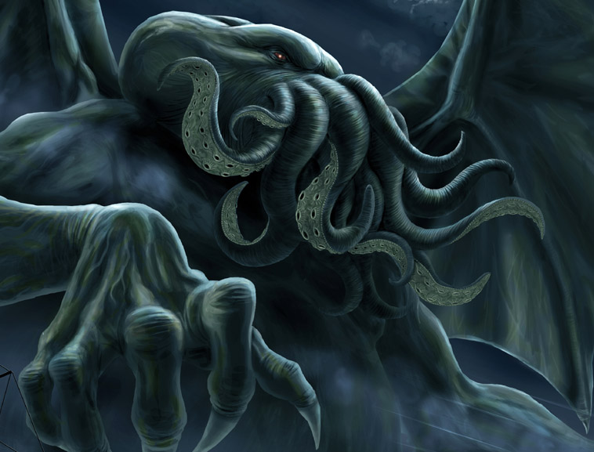
"If Cthulu and Godzilla both rose out of the sea and faced off," Merion says, "we'd all be dead. No human could withstand that kind of fight."
"Yeah, but who would win?"
"Nobody. You can't win a fight if every witness is dead. You might as well flip a coin."
The dryer stops. Merion gets up and opens the door, pulling pieces of clothing out into the machine and tossing them onto the cart. "It's like Schrodinger's cat. If nobody is there to see it, both Cthulu and Godzilla win and lose at the same time, for all eternity."
Merion holds out a shirt, gray with blue stripes, and adds, "I think this is yours."
Most of Jeremy's clothes are variations on the same shades of gray or blue or black. Merion, on the other hand, has the most fantastic clothes Jeremy has ever seen: brightly colored shirts, outrageously patterned pajamas, lacy bras, sparkly bowties, suspenders, soft tweed vests.
Merion is bi-gendered. She is a woman on some days and a man on others, switching out genders on a daily, sometimes hourly, basis. Jeremy has eaten breakfast with Merion when she was wearing a soft, silken sundress that hugged all her curves, and then gone to the movies the same night with Merion while he was wearing a sharp-looking suit, all acute angles and honed features.
On laundry day, though, Merion is only ever Merion: jeans, a t-shirt, maybe a scarf, narrow hips, a high forehead, an enthusiasm for morbid conversations.
They fold clothes and talk about the apocalypse; nuclear holocaust versus global pandemic, robot uprising versus alien invasion. The apocalypse is easy to talk about, existing in some hypothetical territory that is just as easy to believe as to dismiss. Jeremy doesn't mention the poltergeist in his closet. It's harder to talk about than the end of the world.
"Do you ever get lonely?" Jeremy asks the poltergeist, one night when he can't sleep. "Did you miss having someone around? Were you bored without shirts to turn inside out?"
There's no answer, just the lingering smell of apricots and dust. To his knowledge, Jeremy's never eaten an apricot, couldn't pick it out in a lineup of other unfamiliar fruits, so he's not sure why the smell is so identifiable. But it's apricots, not pears or blueberries or any other fruit.
"Or maybe you liked being alone. Maybe that's why you chose that closet, because there was nobody in the room attached to it. Maybe you wanted a solitary life. Afterlife. Whatever."
No answer but the distant noise of traffic, the creak of the overhead fan.
When he checks the next morning, Jeremy notices that the seam of his suit leg has been unraveled past the ankle. Is this an answer to his questions? A sign of affection? Of annoyance?
Merion is feminine today. She's wearing skinny jeans, cherry-red combat boots, a pink t-shirt decorated with cupcakes and rainbow sprinkles.
No matter what permutation of gender Merion is displaying on any given day, the cupcake obsession is a constant.
They're sitting on the floor of a Barnes & Noble, sharing some kind of frothy coffee drink that tastes like a gingersnap cookie. They each have a pile of books and magazines. Merion is paging through a fashion magazine. The smell of perfume samples is wafting into Jeremy's nostrils in an unpleasant way.
Jeremy is looking at a book of nature photography. According to his mother, he's "neurodiverse." He rarely got higher than a B- in his high school classes. He failed out of art school because he couldn't write coherent essays. Words are a source of confusion and disappointment.
He prefers images. Even when they lie, pictures are straightforward about being dishonest.
Merion tosses the fashion magazine onto the ground and opens up Jane Eyre. "I hate sad endings," she announces, to Jeremy and all the other Barnes & Noble patrons within hearing distance.
"Why?" Jeremy asks.
"They're so ubiquitous."
"What does that mean?"
"They're too common. Sad endings have reached epidemic levels in literature. They're infecting everything, even the YA section. Even comics," she adds, pointing at the Death Of Superman in Jeremy's pile of books, Lois Lane cradling the limp, spandex-clad body.
"There are plenty of books with happy endings," Jeremy says, not actually that sure. Literature is not a sure topic for him.
"Yeah, but they're just as bad. You know a sad ending is hovering on the horizon, just out of view, waiting to pounce on the protagonist that's finally found love or meaning or whatever."
"That's why I like art," Jeremy says, studying a photo of a snowshoe hare in the Arctic, white on white, a study in subtlety. "It never leads you on. And if it does, it's only because you let it."
Merion tosses Jane Eyre on top of the magazine. "Sometimes all I want to do is read a silly love story, with some kind of interesting twist. Like a kraken. A kraken is a good twist."
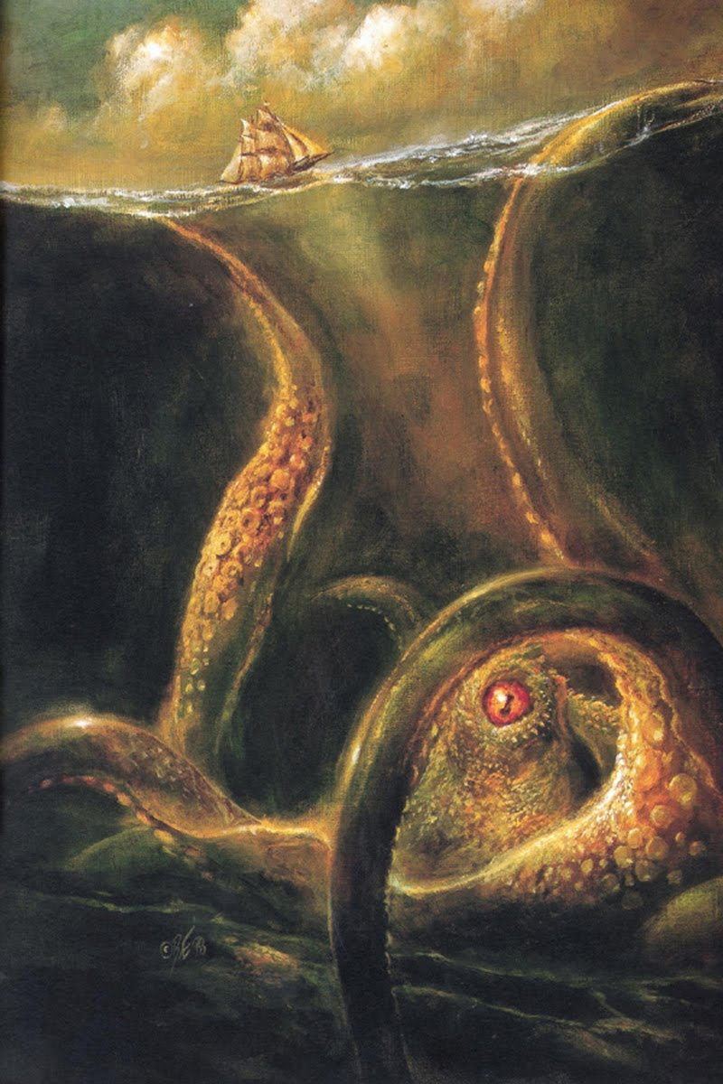
"Like, two krakens in love?"
"Not necessarily. Just a kraken. It doesn't need to have that big of a part."
"What about a poltergeist?" Jeremy asks. "Would that be a good twist?"
Merion cocks her head, considering. "I don't know. I'm not sure how believable that would be."
Jeremy has been in love with Merion for four weeks, since they met at a senior art show at the Art Institute. Jeremy had just been put on academic suspension, had been given five days to move out of his dorm, and had come for the free food. Merion had worn a lavender bowtie, a dark corduroy jacket, and tortoise-shell glasses. His dark hair was slicked back, the curls reduced to subtle shining waves. There was an unlikely tension about him, something unresolved; it drew people's attention and kept them away. Jeremy had watched him from the food table, too intimidated to approach.
Jeremy was eating kalamata olives when a tall brunette with Bettie Page bangs approached Merion. "Sorry," she said. "I just have to ask, are you a girl or a boy?"
Merion glared at her. "I'm Merion."
"Like, as in Maid Marion?"
"Like, as in fuck you," he spat. Jeremy's heart had sped up. It was an odd thing to fall in love with somebody's ferocious vulnerability, but that was the position Jeremy found himself in.
Merion walked away from the sputtering brunette, toward the table that Jeremy had haunted all night, and poured himself a plastic flute of white wine. Jeremy spat out the olive pit in his mouth, and asked, "Merion as in marionberries?"
Merion turned to Jeremy with a cool, assessing look, eyebrows drawn together. "What are those?" Merion asked.
"Hybrid berries," Jeremy said. "They're good in pies."
And then they began talking about the genetic modification of food, whether it was a good thing that would stop world hunger and make better pies, or result in killer mutant strawberries going on a murderous rampage someday.
Merion invited him on their first laundry date the next day. At the Laundromat, Jeremy was given the breakdown on Merion's gender: male some days, female on others, sometimes neither. Just Merion.
"Okay," Jeremy said.
"Okay?" Merion repeated. "That's it? You're not freaked out?"
Jeremy paused, searched inside himself, and said, "Nope."
"You're not going to tell me that using 'they' as a singular pronoun is grammatically incorrect?"
It sounded like Merion had had that argument with a lot of people. "I don't even know what a singular pronoun is."
Merion nodded. Jeremy sensed he'd passed a test. "Okay. One more thing."
"What?"
The washer dinged, and Merion asked, "How do you feel about cupcakes?"
"What do you mean, you have a poltergeist?" Merion asks. They've left Barnes & Noble, because it seemed inappropriate to have conversations about the paranormal in a busy commercial setting. The streets at twilight, in the dim hour before the streetlights came on, were more atmospheric.
"It lives in my closet," Jeremy explains. "It's been there since I moved in.'
"What does it do? Does it rearrange furniture? Or leave trails of ectoplasm?" Merion stops and puts a hand on Jeremy's shoulder. "Does it run a spectral hand down your skin while you're sleeping?"
Jeremy is too aware of the non-spectral hand on him now. "It turns my shirts inside out. And unravels the seams on my suit."
"You have a suit?" Merion asks, disbelieving. Jeremy only ever wears faded jeans, wrinkled shirts, and hooded sweatshirts, often splattered with paint.
"And it smells like apricots," Jeremy said.
"Your suit?"
"The poltergeist."
"Really? Maybe we should do an exorcism."
"No!" Jeremy says. "It's not doing anything bad, and besides, it's been there longer than I have. That doesn't seem fair."
Merion nods her agreement. "It'd be rude to evict it, I guess. Still, it's unraveling your suit--"
"Forget the suit. The suit's ugly, I haven't worn it in years. It probably doesn't fit anymore."
Merion sighs. "Have you tried to communicate with it?"
"I tried talking to it a few nights ago."
"Did it answer?"
"It tore open the seams on my pants." Jeremy thinks about it. "Maybe it doesn't like words."
"Who doesn't like words?" Merion asks. Merion is proud of her vocabulary.
"You can't trust words. They have too many rules, and too many ways to break the rules."
Merion looks skeptical, but then shrugs. After all, the English language isn't particularly charitable to people like Merion, with its rigidly gendered pronouns. "Maybe there's another way to communicate with it. Have you tried Morse code?"
"Maybe I'll draw something for it." Jeremy thinks for a moment. "Let's go to the grocery store."

Apricots, as it turns out, are kind of pretty. They look like small peaches, and they fit perfectly into the palm of Jeremy's hand. He stuffs a dozen into his backpack. Merion brushes one across her lips, touching the softly furred skin to her mouth.
"Try it," she says, when she catches Jeremy looking. She hands him the apricot she's been sort-of kissing.
Jeremy puts his mouth on the same spot. The fruit is cool, the fuzz ticklish against his lips. He can smell the fruit, sweet and fresh, distantly related to the musty smell in his closet.
He bites in. It's not quite ripe, and the fruit is firm and tart. He swallows and gives it back to Merion.
His heart pounds as Merion sucks the pink-yellow flesh, chews it hungrily, bite after bite. When she's done, she spits the pit into her palm and offers it to him. Jeremy wraps it in a napkin and puts it in his pocket, and they walk back outside. It's fully dark out now.
"Do you want to come over?" Jeremy asks.
Merion hesitates. Then, "No. No, I have to--"
"Okay," Jeremy says quickly. He'd rather not be lied to.
Jeremy sets up his easel, his acrylics, his brushes, a jar of water. He takes the frayed suit from his closet and spreads it over the milk crates he's been using as an end table. He doesn't have a big enough bowl to put the apricots in, so he uses a takeout container, piling them in. He puts the pit, a scrap of reddish-pink flesh still clinging to it, on a saucer to the side. 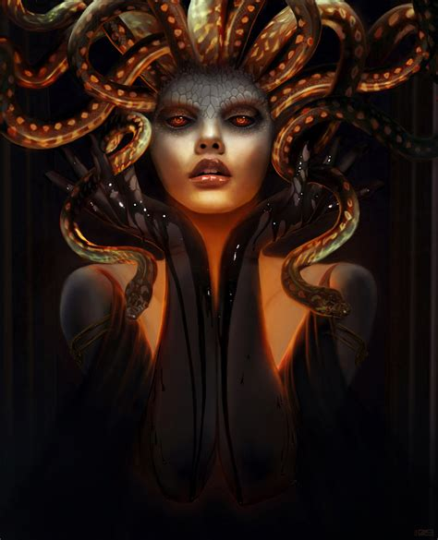
Jeremy doesn't usually paint still life. He likes to paint portraits of monsters. A bust of Cthulu. Medusa in repose. St George being killed by the Dragon. Fenrir devouring the world. Sometimes the monsters were ones that had crawled out of his imagination or nightmares: a spider made of knives, a skeleton dressed in the skin of dead children, creatures with fangs, rotting flesh, scales, claws, hunger, rage, greed.
It is easy for him to imagine the worst things; trying to see exactly what's in front of him is harder.
A plastic container full of living fruit. The streetlight shining through the window. The dangling thread of wool on his suit, the shiny black buttons. His cheap apartment, his spectral roommate, the letter confirming his academic suspension, his infatuation with someone who switches out their gender like it's an attractive but itchy sweater, his mother's disappointment, his dwindling savings.
And the one thing he can't see, can't imagine: his future. That's the monster, really, that's lurking at the corner of this painting. Not the poltergeist in his closet.
He paints for six hours, moving slowly, trying not to scare away the shy vision that's presenting itself to him. When he's finished, he gets up to wash his brushes. He stretches, trying to work the kink out of his lower back, and calls Merion.
"Is it done?" Merion asks, picking up on the second ring.
"Do you think zombies can go through revolving doors?" Jeremy says, because it's an easier question than the one he needs to ask.
"Is it done?" Merion asks again.
"Yeah." A pause, a breath. "Will you come over?"
There's a pause. "No."
"Oh. Okay. Sorry. I'll--"
"I mean, no, I don't think zombies can go through revolving doors. Maybe one or two, but a horde of them would make it jam." There's another pause. "I'll be over in ten minutes. What's your address?"
Merion is wearing jeans shorts, the red combat boots, and a cowboy shirt when Jeremy answers his door. The tortoiseshell glasses are perched on his nose. There is the same tension around him, the air of something left unsaid, as there was at the art opening.
"Let me see it," Merion says.
Jeremy opens the door and lets him in. He expects Merion to go straight for the painting, but instead, he looks at Jeremy's apartment: the beige walls, the boxes of comic books, the stacks of canvases. Unfinished.
"I'm bad at decorating," Jeremy says.
"You are," Merion agrees.
Jeremy wonders what Merion's apartment looks like. Does its decor change as often as Merion does? Is it split down the middle?
No, Jeremy decides. Merion is entirely himself (or herself, or themself). That apartment probably fits together like a Rubik's cube, the same way Merion does, shifting but whole. Jeremy wonders if it's cupcake-themed.
Merion wanders over to the south side of the apartment, where Jeremy set up his easel, the milk cartons, the takeout container of fruit, and looks at his painting.
Jeremy walks over and stands next to him. He doesn't ask, "What do you think," even though he always wants to know what Merion thinks.
They look at the painting for a long time.
Jeremy doesn't say: "If you had to resort to cannibalism, would you eat your mother or your father first?"
He doesn't say: "Would you rather have a parasite that controlled your brain, or singing mushrooms that grew out of your armpits?"
He doesn't say: "Which will happen first, will the supervolcano under Yellowstone blow up, or will the San Andreas fault crack open and spill San Francisco into the sea? How will the world end?"
He says, "I think I'm in love with you."
Merion nods, like this isn't a surprise. "Okay," Merion says. Then he puts a hand on Jeremy's shoulder, turns towards him, kisses him.
His mouth is like an apricot. Closed: warm, firm, lightly furred on his upper lip. Open: wet, tart, hot.
Jeremy's knees feel a little weak, so he sits down in the chair next to the easel. Merion takes this as an invitation to sit down in his lap, straddling Jeremy's hips. His weight is heavy, pressing Jeremy deeper into the wooden chair. Pinning him there.
"What if I'm a woman underneath my clothes?" Merion asks.
"That's fine."
"What if I'm a man?"
"That's fine, too," Jeremy says.
"What if I'm neither? Or both?" Merion leans closer. The chair creaks under their weight. "Or what if I'm a monster? What would you do if I took off my shirt, and you saw scales or tentacles or tumors with tiny, scowling faces?"
Jeremy has always distrusted words, because they pretend to be straightforward but shimmer like heat waves rising off pavement. He likes images because they never pretend to be the whole story. Beyond the borders, an entire world is left to the imagination: here there be dragons.
"I'd ask to paint you," Jeremy answers. "Merion the monster, in repose. With cupcake."
Merion laughs, deep-throated, happy.
In Jeremy's closet, the poltergeist pauses while pulling a shirt off its hanger. Something catches its attention, and it drifts out of the confines of the closet. It ignores the two figures sharing a single chair, pressed chest to chest, mouth to mouth; if one of them is a monster, the poltergeist doesn't care. It picks up the apricot pit from the saucer, examines the scrap of pink flesh clinging to it. It feels like a raw bone, the violent remainder of something that was torn away, chewed up, devoured.
The poltergeist hovers near Jeremy and Merion like a distant ending, ignored but insistent in its presence.
The End
This story was first published on Friday, September 7th, 2012

